Name:________________________________________ Period:________________ Date:_______________
Nature of Science Homework
- Carmen conducted an experiment to determine if listening to different types of music would affect a person’s pulse. Her hypothesis was that pulse rate would change with different types of music. Each person listened to seven different selections of music for 30 seconds each. Each person’s pulse was taken before the music and then after each 30-second interval of music. The pulses were taken again after the music selections were completed. Based on her experiment, Carmen concluded that a person’s pulse rate changed when the person listened to different types of music. Which component is missing from Carmen’s experiment?
  - a question
  - a hypothesis
  - a control group
  - a description of the experiment
- A research group has discovered that damselflies, a type of dragonfly, are being infected by a particular type of aquatic protozoan. Both young and adult damselflies are not directly infected by the protozoan but contract the infection from the prey they eat. The graph shows the percentage of adult damselflies infected by protozoans during the summer and early fall.
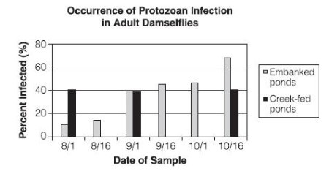
Which of the following conclusions is supported by the graph?
- Infection in embanked ponds increased during the sampling period.
- Protozoans were more common in creek-fed ponds than embanked ponds.
- Protozoans reproduce more quickly in embanked ponds than creek-fed ponds.
- Infection in creed-fed ponds remained constant throughout the sampling period.
- The graph below shows atmospheric carbon dioxide levels since the year 1880.
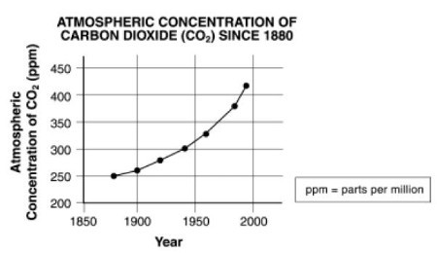
Which of the following conclusions can be drawn from this graph?
  - Atmospheric carbon dioxide levels are responsible for global temperature change.
  - Atmospheric carbon dioxide levels have been rising at about the same rate for the past century
  - Atmospheric carbon dioxide levels have remained the same over the past century.
  - Atmospheric carbon dioxide levels have been rising at an increasingly higher rate as the past century has progressed
- A scientist performs an experiment to see if acids have an effect on the health of a particular type of plant. Three sets of plants were treated with acidic solutions of known pH while the control set was treated with a solution of neutral pH 7.
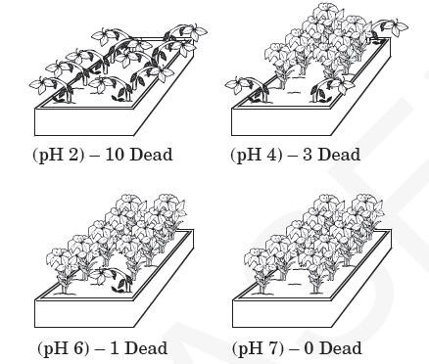
Which is the best conclusion for this experiment?
  - Acid has no effect on the health of this type of plant.
  - High acidity is helpful to this type of plant.
  - Low acidity is harmful to this type of plant.
  - High acidity is harmful to this type of plant.
- Based from what you learned today, answer today’s essential question “How can you tell the difference between Science and Non-Science?” Be sure to use examples to support your explanation.
____________________________________________________________________________________________________________________________________________________________________________________________________________________________________________________________________________________________________________________________________________________________________________________________________________________________________________________________________________________________________________________________________________________________________________________________________________________________________________________________________________________________________________________________________________________________________________________________________________________________________________________________________________________________________________________________________________________________

