Basic Chemistry Review
Why is matter important?
What is matter made of?
What are the most common elements in the body and their mass percents?

What is a molecule?

Example:
Chemical Formulas:
- Symbols represent individual elements and subscripts represent how many atoms of an element there are in a compound
- Example: CO2 = 2 oxygen atoms and 1 carbon atom
What is a macromolecule?
- Macro =
- Molecule =
- Macromolecule=
Why are macromolecules important?

Monomers=
Polymer=
4 main macromolecules in living organisms:

Carbohydrates
Functions:

Monomer=
Made of these elements:
Structure: 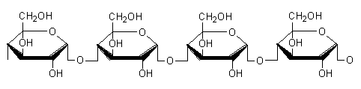
Monosaccharide:
Disaccharide:
Polysaccharide:
How can you tell from the name it is a sugar?
Examples of carbohydrates:

Lipids
Examples of lipids:

Functions:

Monomer=
Made of these elements:
Structure:
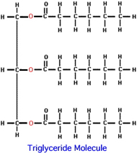

Parts of a lipid:

