Proteins
Functions:

Polymer=
Monomer=
Made of these elements:
Structure:
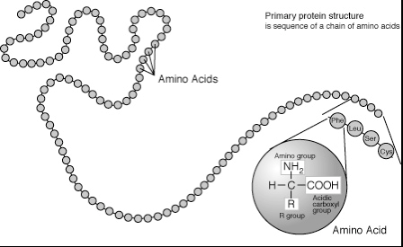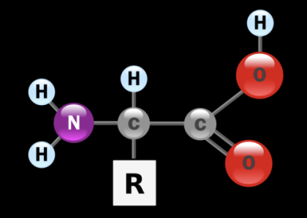

Amino Acids:

Why do we need proteins?

Function of Proteins:

STRUCTURE DETERMINES FUNCTION
Examples of proteins:

Nucleic Acids
Examples of nucleic acids:

Functions:

Monomer=
Polymer=
Nucleotides are made of:
Structure:
