Name:__________________________________ Period:________________ Date:____________

The element carbon
Carbon has four electrons in its valence shell (outershell). Since this energy shell can hold eight electrons, each carbon atom can share electrons with up to four different atoms. Carbon can combine with other elements as well as with itself. This allows carbon to form many different compounds of varying size and shape.
Carbon alone forms the familiar substances graphite and diamond. Both are made only of carbon atoms. Graphite is very soft and slippery. Diamond is the hardest substance known to man. If both are made only of carbon what gives them different properties? The answer lies in the way the carbon atoms form bonds with each other.
Notice that graphite is layered.
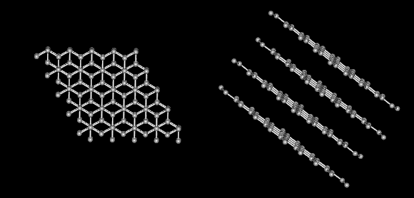
There are strong covalent bonds between carbon atoms in each layer. But, only weak forces exist between layers. This allows layers of carbon to slide over each other in graphite.
On the other hand, in diamond each carbon atom is the same distance to each of its neighboring carbon atoms. In this rigid network atoms cannot move. This explains why diamonds are so hard and have such a high melting point.
After reading about the structure of carbon, use what you learned in class to answer: why you think the unique structure of carbon is important to forming macromolecules and to life in general? Use your textbook for additional help and the back of this paper for space if you need it.
__________________________________________________________________________________________________________________________________________________________________________________________________________________________________________________________________________________________________________________________________________________________________________________________________________________________________________________________________________________________________________________________________________________________________________________________________________________________________________________________________________________________________________________________________________________________________________________________________________________________________________

