**NAME:________________________________________________ PER:_____________ DATE:_______________________ SCORE:______**

**L.18.1 Macromolecules Independent Practice – 10 points**

1. Fill in the following table:

|  |  |  |
| --- | --- | --- |
| Macromolecule | Monomer | Polymer |
| Proteins |  |  |
| Carbohydrates |  |  |
| Nucleic Acids |  |  |
| Lipids |  |  |

1. Below are the images two of 2 naturally occurring monomers. Identify what type of monomer they are and the polymer that they make up.

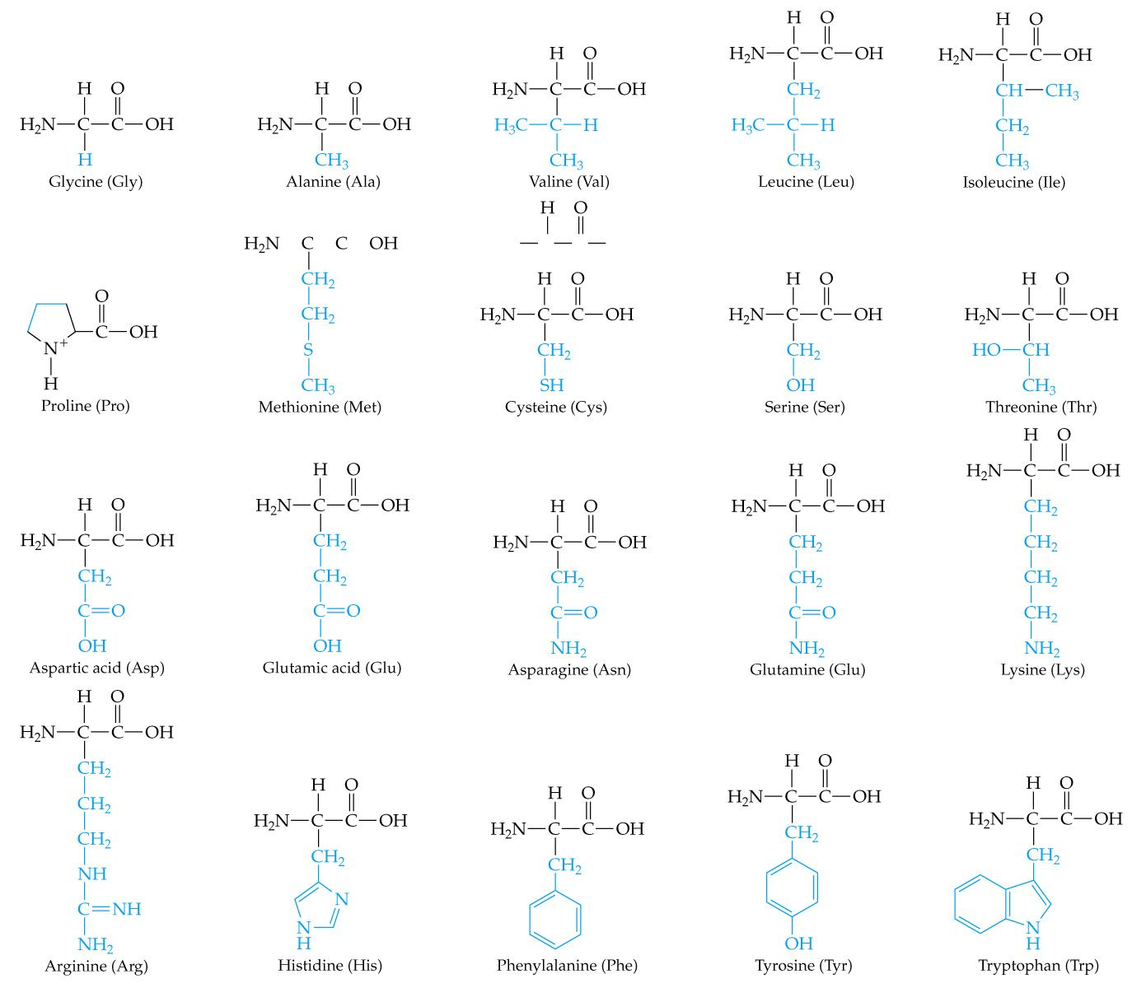

Monomer: ______________________________________________________

Polymer: ______________________________________________________

1. Below is a list of 2 patient’s breakfasts. Identify which patient ate the healthier breakfast and explain why you chose that patient.

|  |  |
| --- | --- |
| Patient A | Patient B |
| Whole grain toast  2 eggs – scrambled, cooked in butter  Avocado slices  Tomato slices | McDonalds Sausage Egg McMuffin   * White English muffin * 1 egg – fried in vegetable oil * American cheese * Sausage – cooked in vegetable oil |

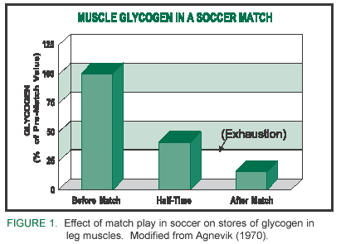________________________________________________________________________________________________________________________________________________________________________________________________________________________________________________________________________________________________________________________________________________________________________________________________________________________________________________________________________________________

1. This graph details the decrease in muscle glycogen in athletes over the course of a soccer match. To replenish their glycogen, soccer players eat starches like pasta and bread. Identify the monomer and polymer of the macromolecule category glycogen falls into. Then describe why glycogen decreases over the course of a game.

(Hint: keep in mind the macromolecule you identified’s function). (4 pts)

Monomer: __________________________________

Polymer: ___________________________________

____________________________________________________________________________________________________________________________________________________________________________________________________________________________________________________________________________________________________________________________________________________________________________________________

1. Monosaccharide is to carbohydrate as _______________________________ is to proteins.
2. Lipids function is to store energy as proteins function is to ________________________________.
3. Amino acids are to proteins as nucleotides are to _________________________________.
4. A macromolecules’ structure determines its ________________________________________.
5. Carbohydrates main function is as a source of energy while nucleic acids main function is to _______________________________.
6. The diagrams below represent four different molecules:

Which two diagrams represent the building blocks of lipids?

1. A and B (3) C and D
2. B and D (4) A and C

**For *each* phase in questions 11-15, select the molecule, *chosen from those shown below*, which is best described by that phrase.**

1. These two structures are used for the formation of bones and muscles.
2. An example of a carbohydrate.
3. This structure represents the structure of oil.
4. An example of a lipid.
5. This molecule is used as the main source of energy in plants and animals.
6. Describe at least one function of ­each group of organic compounds (there are four of them)
7. What properties of carbon explain carbon’s ability to form many different macromolecules?
8. Explain the relationship between monomers and polymers, using polysaccharides as an example.