Name: ________________________________ Period: _______ Date: ____________________ Score: _______________

Enzymes Activity 2-Evaluating Graphs

- Basic Graphs
Enzyme Efficiency
Temperature Temperature Acid Base Acid Base
(a) (b) (c) (d)

Word Bank: low temperature, high temperature, medium temperature, acidic, basic. (5 pts each)
  - Graph (a) shows that this enzyme will work best at what type of temperatures?
  - Graph (b) shows that this enzyme will work best at what type of temperatures?
  - Graph (c) shows that this enzyme will work best at what type of pH?
  - Graph (d) shows that this enzyme will work best at what type of pH?

- Create a Line Graph that demonstrates the data table to the right. (20 pts.)

 | pH | Enzyme A  Efficiency | Enzyme B  Efficiency
Acidic | 0 | 10 | 0
 | 1 | 30 | 0
 | 2 | 55 | 0
 | 3 | 75 | 0
 | 4 | 90 | 0
 | 5 | 85 | 20
Neutral | 6 | 70 | 35
 | 7 | 60 | 45
 | 8 | 35 | 50
Basic | 9 | 20 | 65
 | 10 | 0 | 80
 | 11 | 0 | 55
 | 12 | 0 | 40
 | 13 | 0 | 30
 | 14 | 0 | 20

(4 pts each)
  - At what pH does enzyme A work best at?
  - At what pH does enzyme B work best at?
  - How high was the enzyme efficiency for enzyme A at a pH of 8?
  - Which enzyme works best at a basic pH?
  - Which enzyme is the most efficient at any pH?

III. Evaluating Graphs (5 pts each)
Below you’ll find graphs that show how pH affects four different enzymes. For each, explain the trend you see, and where the enzyme is most efficient, shown by the optimum, or best pH.
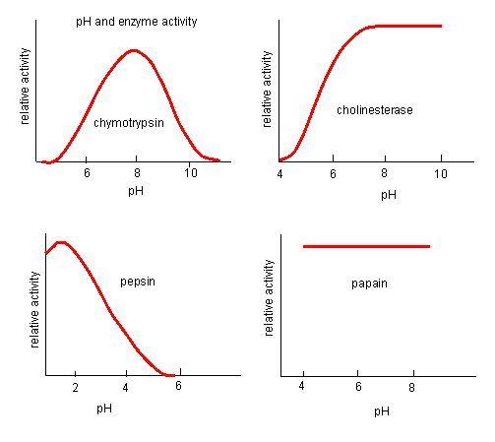
I. Chymotrypsin (enzyme that digests proteins)::

II. Cholinesterase (enzyme that affects neurotransmitters):

III. Pepsin (enzyme that digests proteins):

IV. Papain (enzyme in papaya):

IV. Pulling it all together
Answer the following question based on the table below :
Enzyme | Effective Temperature (◦C) | Optimum pH
A | 60-80 | 3
B | 30-40 | 5
C | 20-38 | 9
D | 20-27 | 7
If enzyme C is functioning at 20 degrees Celsius and a pH of 7, under which conditions would the rate of enzyme activity probably increase?
- The temperature is decreased to 22 degrees and the pH is kept the same.
- The temperature is increased to 30 degrees Celsius and the pH is increased to 8.
- The temperature is kept the same and the pH is decreased to 6.
- The temperature is increased to 44 degrees Celsius and the pH is kept the same.
Explain why: (20 pts.)
_________________________________________________________________________________________________________________________________________________________________________________________________________________________________________________________________________________________________________________________________________________________________________________________________________________________________________________________________________________________________________________________________________________________________________

