Name: _____________________________________ Date: ____________ Period: _________ Score: ______
Biology L.16.3 DNA Replication (10 points)
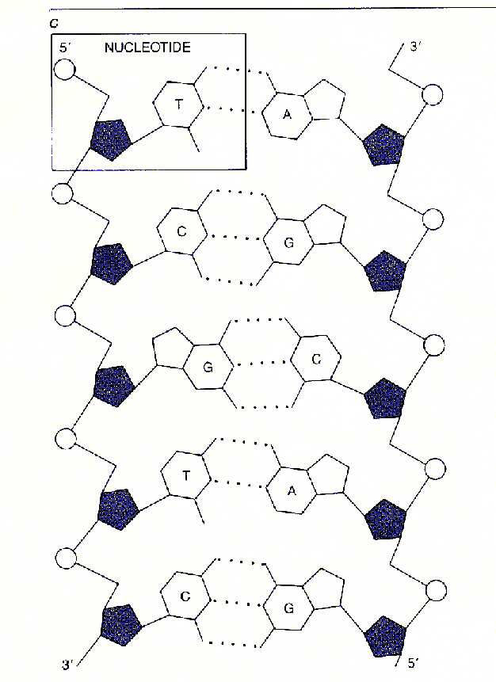
a quote from the document or the summary of an interesting point. You can position the text box anywhere in the document. Use the Text Box Tools tab to change the formatting of the pull quote text box.]
Use the picture to the right to answer questions 1-5:
- The molecule inside of the box represents one monomer that make up a strand of DNA. This monomer is called a __________________. When you have more than one of these boxes it makes a _____________________ of DNA.
[Type a quote from the document or the summary of an interesting point. You can position the text box anywhere in the document. Use the Text Box Tools tab to change the formatting of the pull quote text box.]
X
- Label the diagram:
X: _________________________________
Y: _________________________________
[Type a quote from the document or the summary of an interesting point. You can position the text box anywhere in the document. Use the Text Box Tools tab to change the formatting of the pull quote text box.]
Y
Z: _________________________________
[Type a quote from the document or the summary of an interesting point. You can position the text box anywhere in the document. Use the Text Box Tools tab to change the formatting of the pull quote text box.]
Z
- We know this a molecule of DNA because it is _____________ stranded. Also, unlike RNA this strand has the base ________________ instead of uracil.
[Type a quote from the document or the summary of an interesting point. You can position the text box anywhere in the document. Use the Text Box Tools tab to change the formatting of the pull quote text box.]
[Type a quote from the document or the summary of an interesting point. You can position the text box anywhere in the document. Use the Text Box Tools tab to change the formatting of the pull quote text box.]
[Type a quote from the document or the summary of an interesting point. You can position the text box anywhere in the document. Use the Text Box Tools tab to change the formatting of the pull quote text box.]
[Type a quote from the document or the summary of an interesting point. You can position the text box anywhere in the document. Use the Text Box Tools tab to change the formatting of the pull quote text box.]

- Explain the base pairing rule: __________________________________________
__________________________________________
__________________________________________
__________________________________________
[Type a quote from the document or the summary of an interesting point. You can position the text box anywhere in the document. Use the Text Box Tools tab to change the formatting of the pull quote text box.]
__________________________________________
__________________________________________

- Using the base pairing rule, fill in the appropriate matching bases on the right strand in the empty hexagon shapes.
[Type a quote from the document or the summary of an interesting point. You can position the text box anywhere in the document. Use the Text Box Tools tab to change the formatting of the pull quote text box.]

- Fill in the missing base pairs in the DNA molecule.
G C T A __ __ __ C A __ __ __ __ C G C A
__ __ __ __ T A C __ __GG C A G __ __ __ __
[Type a quote from the document or the summary of an interesting point. You can position the text box anywhere in the document. Use the Text Box Tools tab to change the formatting of the pull quote text box.]

  - In a portion of a gene, the nitrogenous base sequence is G-G-C-T-A-T. In a DNA molecule, which nitrogenous base sequence would normally be found bonded to this section of the gene?
___ ___ ___ ___ ___ ___
  - If you wanted to produce a RNA molecule from the original strand G-G-C-T-A-T, which nitrogenous base sequence would result?
___ ___ ___ ___ ___ ___
- The nitrogenous base cytosine makes up 15% of all of the nitrogenous bases in the DNA of a cell.
  - Since cytosine is base paired with guanine, then guanine should make up _____% of all the nitrogenous bases.

  - When you add cytosine and guanine’s percentage of all the nitrogenous bases in the DNA of a cell, you would get __________%. Assuming all 4 bases add up to 100%, this leaves _________% for adenine
and thymine.

  - Therefore, adenine must make up ____% of all the nitrogenous bases and thymine must make up ____% of all the nitrogenous bases.

- A scientist found that thymine made up 30% of all of the nitrogenous bases in the DNA of a new type of bacteria she discovered. She is trying to predict what the percentage of the remaining bases are and came up with the following table:
Base | Percent Composition
Thymine | 30%
Guanine | 30%
Adenine | 25%
Cytosine | 25%
You were asked to evaluate her data. Is her table correct or incorrect? Explain your answer.
______________________________________________________________________________________
______________________________________________________________________________________
______________________________________________________________________________________
______________________________________________________________________________________
______________________________________________________________________________________
- In the boxes below, explain each step of DNA replication and include a small picture illustration of each step.

- DNA strand X is a copy made from DNA strand Y. What of the following statements is true about these molecules?
  - They each have different combinations of guanine, adenine, thymine, and cytosine.
  - Each strand consists of one new strand and one old strand.
  - They were both made by a process called protein synthesis.
  - They are opposite of one another.
Using your answer choice, explain why DNA replication is known as a “semi-conservative” process: _______________________________________________________________________________________________________________________________________________________________________________________________________________________________________________________________________________________

