PROTEIN SYNTHESIS MAKES SENSE!

SC.912.L.16.5: Explain the basic processes of transcription and translation, and how they result in the expression of genes.

Objective:
Students understand the role of DNA, mRNA, tRNA, and amino acids in the process of protein synthesis.
Students will use the steps of transcription and translation to assemble a protein that forms a sentence.

Introduction:
Transcription converts a DNA message into an intermediate molecule, RNA. Transcription is similar to the process of replication as both occur in the nucleus, both involve unwinding the DNA and both involve complementary base paring. The process of replication results in one identical copy of the template DNA. However, the process of transcription can result in a many forms of RNA. The mRNA molecule created from transcription can be seen as a temporary copy of RNA.

The final product of transcription, RNA, differs from DNA in three specific ways. First the sugar in RNA is ribose instead of deoxyribose. Second, RNA is a single strand of nucleotides as compared to two in DNA. Third, RNA uses the base Uracil (U) in place of Thymine (T). Uracil, similar to Thymine, pairs with Adenine.

The process of transcription occurs in the nucleus of the cell. Once transcription is complete the RNA message, mRNA, leaves the nucleus where it is taken to a ribosome in the cytoplasm of the cell. When the mRNA arrives at the ribosome translation may begin.

Translation is the process of interpreting the mRNA message into a string of amino acids, called a polypeptide. The process of translation interprets or reads the mRNA by matching the codons on the mRNA to corresponding anti codons on the tRNA. The tRNA transfers amino acids from the cytoplasm to the ribosome to help form a growing protein. The final product of translation is a single polypeptide or many polypeptides working together make up a protein.

In this activity you will transcribe a DNA template strand in the nucleus to an mRNA message. Then you will transport the mRNA to the ribosome (your desk) for translation. Once you have your mRNA message at the ribosome, your desk, you will translate the message into a specific sequence of words. Normally, an mRNA sequence of nucleotides will be translated into a specific set of amino acids using an mRNA Codon chart. However, today we will first translate it into a specific sentence then into an amino acid sequence. Be careful of mutations! If your sentence does not make sense then you may not have transcribed or translated your DNA correctly. Go back and check your process before translating your sequence into amino acids.

Procedures:
- Nucleus: One team member from the group is to pick a strand of DNA from the Nucleus. While in the nucleus, the team member is to copy the DNA template strand (bold strand) and template number on to your student handout next to the section titles “DNA template.”
Transcribe your DNA template strand into mRNA in the box labeled “mRNA / Codons.” As you transcribe your DNA remember to group the RNA nucleotides into codons.

- Ribosome: Return back to the ribosome, your group, and share your DNA template and mRNA with your team members. Everyone should copy the template strand into the box labeled “DNA Template” on the student handout. Your group members should check for accuracy of the mRNA strand then copy it into their student handout.
- tRNA / Anticodon: Determine the correct anticodon you will need to find to translate your sentence. Write the anticodon in the box labeled “Anticodon / tRNA”
- Members from your group are to locate the appropriate anticodon on the tRNA that is located around the room. Each tRNA will have a word on the back that corresponds with the tRNA. Write your words in the correct order to form a sentence.
- If your sentence does not make sense or is not complete you may have a mutation and may need to double check your transcription and translation process.
- Report your protein sentence: Report your sentence to your teacher to check for accuracy.
- Genetic Code: Use the Genetic Code to translate your mRNA to the appropriate amino acid or function.
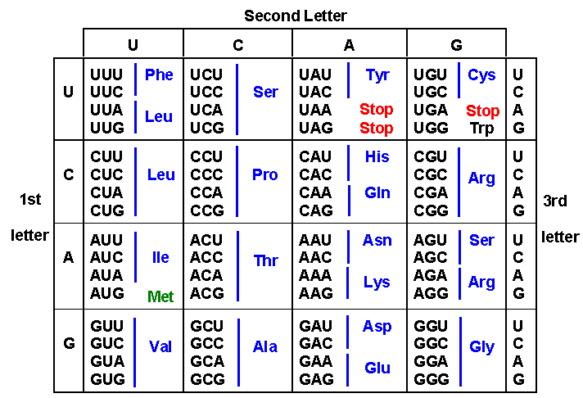
- Repeat steps 1-5 for at least 2 more DNA strands.
Genetic Code: mRNA Codons
The genetic code matches each mRNA codon with its amino acid or function.

Name of Process: | Template DNA #_____
 | mRNA / Codons
Name of Process: | tRNA / Anticodon
 | Sentence
(Use mRNA & Genetic Code)
Amino Acid Sequence
Name of Process: | Template DNA #_____
 | mRNA / Codons
Name of Process: | tRNA / Anticodon
 | Sentence
(Use mRNA & Genetic Code)
Amino Acid Sequence
Name of Process: | Template DNA #_____
 | mRNA / Codons
Name of Process: | tRNA / Anticodon
 | Sentence
(Use mRNA & Genetic Code)
Amino Acid Sequence

Name:_________________________________________ Period:__________________ Date:______________

Protein Synthesis Makes Sense!

Question: What are the steps in the process of protein synthesis?

Hypothesis: ________________________________________________________________________________________________________________________________________________________________________________________________________________________________________________________________________________________________________________________________________________________________________

Materials and Methods: __________________________________________________________________________________________________________________________________________________________________________________________________________________________________________________________________________________________________________________________________________________________________________________________________________________________________________________________________

Summarize in your own words, the introduction to this lab: ____________________________________________________________________________________________________________________________________________________________________________________________________________________________________________________________________________________________________________________________________________________________________________________________________________________________________________________________________________________________________________________________________________________________________________________________________________________________________________________________________________________________________________________________________________________________________________________________________________________________________________________________________________________________________________________________________

Data: see next page

Analysis:

- Why did you have to stay in the "nucleus" to write down the mRNA?

- Which part of this activity represents transcription?

- Which part of this activity represents translation?

- Explain the basic processes of transcription and translation.

- What does the final sentence represent in terms of protein synthesis?

- What does each word represent in terms of protein synthesis?

- Explain the significance of the start and stop codon.

- Explain how both transcription and translation result in the expression of genes.

- If one nucleotide was inserted or deleted in the DNA explain how this would impact protein synthesis.

EOC Style Questions
- A diagram of a cellular process is shown below.

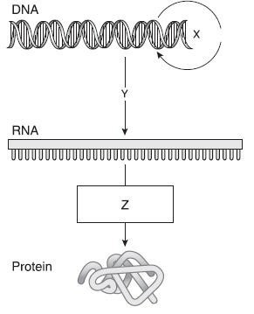
Which of the following identifies the process shown at point Z?
- Translation
- Translocation
- Replication
- Transcription

- During transcription the DNA base sequence is transcribed into a complimentary mRNA sequence. A codon table like the one shown below lists the amino acids coded for by particular triads of mRNA bases. A segment of DNA has undergone a mutation in which one nucleotide has been changed. The original sequence was ACG and the new sequence is ACA. Use the codon table to determine whether or not this mutation will cause a change in the phenotype of the organism.

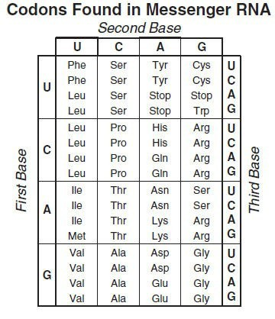
  - Yes, the phenotype of the organism would change because a new amino acid will be coded for.
  - Yes, the phenotype of the organism would change because any change in the DNA sequence will cause a change in phenotype.
  - Even though the DNA sequence changed, the sequence still codes for the same amino acid, so no change in phenotype will occur.
  - It is impossible to determine if a change in phenotype will occur using only the DNA sequence.
D

