**Observing Plasmolysis in Plant Cells**

**Background**:

Movement of water molecules across a cell membrane from areas of low solute concentration to areas of high solute concentration is called **osmosis**. This movement of water, in certain circumstances, can be harmful to cells. It can result in severe cell water loss when living cells are placed into a **hypertonic** environment where the solute concentration outside the cell is much higher than inside the cell. This is called **plasmolysis**, and it can be seen under a microscope when the cell contents pull away from the rigid cell wall as the water moves out. However, most cells live in an environment where movement of water in and out of the cell is about equal, **isotonic**, and therefore there are no harmful effects to the cell. In this lab, you will create a hypotonic, hypertonic and isotonic environment for the plant cell and observe the movement of water across the cell membrane.

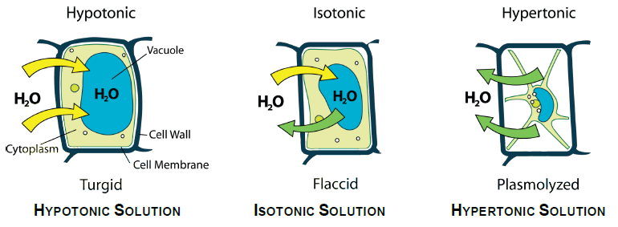

**Materials**

* Microscope
* Plant Leaves
* Microscope Slides
* Cover Slips
* Pipets
* Forceps
* Paper Towel
* 5% Salt Solution
* 10% Salt Solution
* .9% Salt Solution

**Procedure**

**Plant Cells in tap water**

1. Prepare a wet mount of an Elodea leaf with tap water. To do this, use the forceps to place the leaf in the center of the flat side of the glass slide. Flatten the leaf as much as possible. Use the pipet to place one or two drops of distilled water onto the leaf so it is covered, as shown in Figure 1.

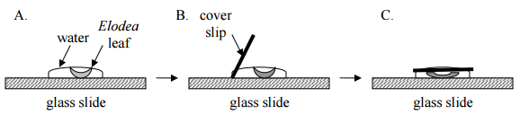

Figure 1

1. Observe the leaf at 40X and record your observations.

* Label the magnification under which the plant cells are being observed (40x or 100x).
* Make your sketches as accurate as possible. Increase the magnification to 100X, observe, and record your observations.
* Be sure to label the cell wall, cytoplasm, and chloroplasts. Also note the movement of the chloroplasts (the green things inside each cell) – this movement is called **cytoplasmic streaming**.

1. Increase the magnification to 100X, observe, and record your observations. Include labels as above.

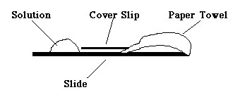

**Plant Cells in 5% Salt Solution (Hypertonic Solution)**

1. Remove the slide from the stage of the microscope.
2. Place 2 drops of the 5% salt solution on the slide at the left edge of the cover slip.

Figure 2

1. Tear off a small piece of paper towel and place the torn edge on the slide at the right edge of the cover slip. The piece of towel should begin to soak up water, drawing the salt solution under the cover slip as it does so. (See Figure 2)
2. Return the slide to the microscope stage and observe the cells at 40X and 100X. Record your observations and include labels as listed above.

**Plant Cells in 10% Salt Solution (Hypertonic Solution)**

1. Repeat the procedure above with 10% salt solution.
2. Observe the cells at 40X and 100X. Record your observations and include labels as listed above.

**Flushing Out the Salt Solution (Rehydration – Hypotonic Solution)**

1. Remove the slide from the stage of the microscope.
2. Place 3-5 drops of tap water on the slide at the cover slip.
3. Draw the water through using a small piece of paper towel.
4. Observe the cells at 40x and 100x. Record your observations and include labels as listed above.
5. Remove the slide from the stage, throw the leaf away, and rinse off the slide and cover slip. Return materials to locations indicated by your teacher.

**Plant Cells in .9% Salt Solution (Isotonic Solution0**

1. Remove the slide from the stage of the microscope.
2. Place 2 drops of the .9% salt solution on the slide at the left edge of the cover slip.
3. Tear off a small piece of paper towel and place the torn edge on the slide at the right edge of the cover slip.
4. The piece of towel should begin to soak up water, drawing the salt solution under the cover slip as it does so. (See Figure 2)
5. Return the slide to the microscope stage and observe the cells at 40X and 100X. Record your observations and include labels as listed above.

|  |  |
| --- | --- |
| **Observing Plasmolysis Lab Sheet** | |
| **Plant Cells in Tap Water 40X**   |  | | --- | |  | | Magnification: ______________ | | **Plant Cells in Tap Water 100X**   |  | | --- | |  | | Magnification: ______________ | |
| **Plant Cells in 5% Salt Solution**   |  | | --- | |  | | Magnification: ______________ | | **Plant Cells in 10% Salt Solution**   |  | | --- | |  | | Magnification: ______________ | |
| **Plant Cells Rehydrated**   |  | | --- | |  | | Magnification: ______________ | | Don’t forget to record the magnification  Be sure to label the cell wall, cytoplasm, and chloroplasts |

**Post Lab Questions**   
Answer the following questions in your lab notebook.

1. Describe what happened to the *Elodea* cells in the presence of 5% salt solution.
2. Describe what happened to the *Elodea* cells in the presence of 10% salt solution.
3. Why didn't the salt from the outside just move inside the cell instead of the water moving out of the cell?
4. Why didn't the cell wall shrink?
5. Describe what happened when you flushed out the salt solution with tap water.
6. Describe what happened to the *Elodea* cells in the presence of .9% salt solution.
7. *Elodea*normally lives in fresh water. What changes would you observe in the cells of an *Elodea* plant that was suddenly moved from fresh water to salt water? Why?
8. Would the plant cells burst when exposed to a hypotonic environment? Why or why not?
9. Would you expect an animal cell to burst when exposed to a hypotonic environment?
10. In the winter, roads are sometimes salted to melt ice and snow. What does this salting do to the vegetation along the roadside? Explain your answer in terms of osmosis.
11. When a person is given fluid intravenously (an I.V.) in the hospital, the fluid is typically a saline solution isotonic to human body tissues. Explain why this is necessary.
12. What if the unthinkable happened at the hospital! A patient was given an I.V. bag with distilled water in it rather than saline solution. Describe what would happen to their red blood cells and explain why this would occur.
13. Explain why soft-bodied invertebrates, like slugs, die when you pour salt on them.

|  |  |  |  |
| --- | --- | --- | --- |
| **Direction of Osmosis:**  **Conditions** | **Environment**  **solution is** | **Cell**  **solution is** | **Water (net movement)** |
| 1. SALINE: If a solute concentration in the environment is higher than in the cell, | _________tonic. | _________tonic. | will move _____ the cell. |
| 1. DISTILLED: If a solute concentration in the environment is lower than in the cell, | _________tonic. | _________tonic. | will move _____the cell. |
| 1. If a solute concentration in the environment is equal to that in the cell, | _________tonic. | _________tonic. | (what happens???) |

1. Carrot sticks that are left in a dish of freshwater for several hours become stiff and hard. Similar sticks left in a saltwater solution become limp and soft. From this we can deduce that the freshwater is ______ and the saltwater is ________ to the cells of the carrot sticks.

A. hypotonic, hypertonic

B. hypotonic, hypotonic

C. hypertonic, hypertonic

D. hypertonic, hypertonic

1. In an emergency trauma room, a doctor accidentally gives a patient a large transfusion of distilled water directly into one of his veins instead of blood. Predict what might happen if distilled water was given to the patient instead of blood.
2. have no unfavorable effect as long as the water was sterile
3. have serious, perhaps fatal effects because there would be too much fluid for the heart to pump.
4. have serious, perhaps fatal effects because the red blood cells would tend to shrivel
5. 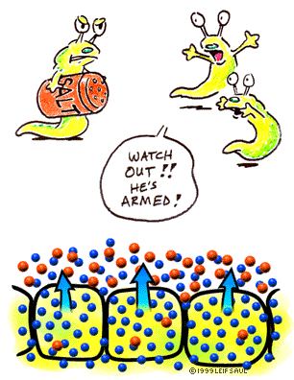have serious, perhaps fatal effects because the red blood cells would tend to burst
6. In pure water, a red blood cell from an animal will swell and burst, but a leave cell from a plant will not. Which structure in the leaf cell is responsible for this difference?

A. cell membrane

B. Cell Wall

C. Mitochondria

D. Nucleus