Directions- Answer each question with a complete sentence. Each question is worth 5 points.

- Define osmosis-_______________________________________________________________________
____________________________________________________________________________________

- Define diffusion-______________________________________________________________________
____________________________________________________________________________________

- Draw a diagram of the cell membrane (phospholipid bilayer). Label the hydrophobic and hydrophilic parts of the cell membrane.

- What is “selectively permeable”? ___________________________________________________________
____________________________________________________________________________________

- Why can we call a cell membrane selectively permeable?________________________________________
____________________________________________________________________________________

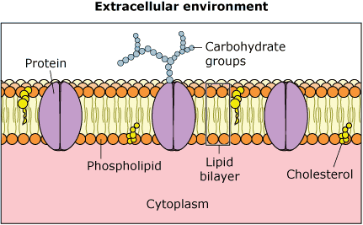
- What is the main way that diffusion and facilitated diffusion differ? _____________________________________
- In the diagram to the right which structure is responsible for transporting molecules across the membrane that are too large to fit?
_____________________________________________

- Which types of transport require energy? ____________________________________

- Which types of transport do NOT require energy? ___________________________________________________

- Fill in the following chart:

Transportation Type | Movement of Particles  (in terms of concentration gradients) | Energy Required? | Use of a Channel?
Osmosis | _________ concentration _________ concentration
Diffusion | _________ concentration _________ concentration
Facilitated Diffusion | _________ concentration _________ concentration
Active | _________ concentration _________ concentration

- Which substance will the membrane not be permeable to?

- Describe the movement of each molecule.
  - ___________________________________________
  - ___________________________________________
  - ___________________________________________

Draw a cell in a hypotonic, hypertonic, isotonic solution. Draw and label the cell, the solutes and the solution.
15
14
13

Hypertonic Hypotonic Isotonic
Directions (for the rest of the problems):
- Determine the water content both inside and outside the cell.
- Draw an arrow representing the direction the water would diffuse.
- State whether the solution is hypertonic, hypotonic, or isotonic.
Example:
17
16

15% salt
8% salt
81% water

9% Oxygen
4% NaCl
79% water

Water content inside = ___81____% Water content inside = _________% Water content inside = __________
Water content outside = ___79___% Water content outside = ________% Water content outside = _________
Type of solution = Hypertonic Type of solution = ______________ Type of solution = ______
What will happen to the cell? What will happen to the cell? What will happen to the cell?
__It will shrivel_________________ _______________________________ _______________________________

20
19
18

91% water
85% water
77% water

8% Glucose
7% Potassium
9% CO₂

Water content inside = __________ Water content inside = __________ Water content inside = __________
Water content outside = _________ Water content outside = _________ Water content outside = _________
Type of solution = ______________ Type of solution = ______________ Type of solution = ______________
What will happen to the cell? What will happen to the cell? What will happen to the cell?

___________________________ _____________________________ _______________________________

