Imagine if someone wanted to cut down all of the trees on Earth. How would this impact your life and the lives of other animals on the planet?

Key Point #1: Photosynthesis and Cellular Respiration are interrelated.

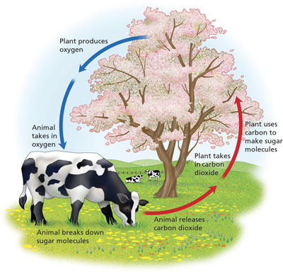

Key Point #2: Photosynthesis and Cellular respiration are opposites of each other.

How are the reactants and products related to each other?
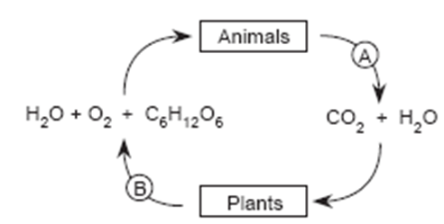
What do you notice about this diagram?
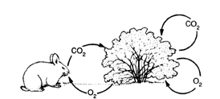

What is the difference between what happens to energy during photosynthesis vs. during cellular respiration?

Key Point #3-Photosynthesis captures energy and cellular respiration releases energy.

What types of organisms do photosynthesis? What types do cellular respiration?

Key Point #4- Plants use both cellular respiration and photosynthesis, while animals only use cellular respiration.

