Function:  Tissue Types found in the leaf:  Processes leaf is involved in: | Structures
Function:  Tissue Types found in the stem:  Processes stem is involved in: | Structure  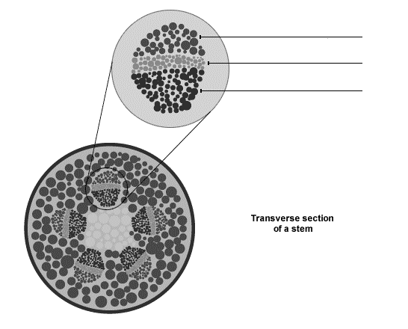
Function:  Tissue Types found in the root:  Processes root is involved in: | 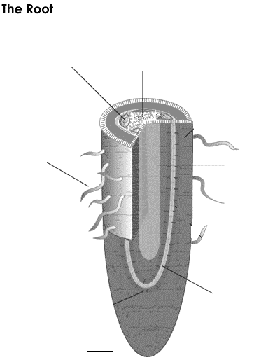  Structure
