Elephant vs. Lion:

What needs to move in and out of a cell?

How does a cell deal with its size problem?

Mitosis= the division of a parent cell to form two identical daughter cells.
Cell division= the process by which a cell divides into two daughter cells. Before division occurs, a cell copies all of its DNA.

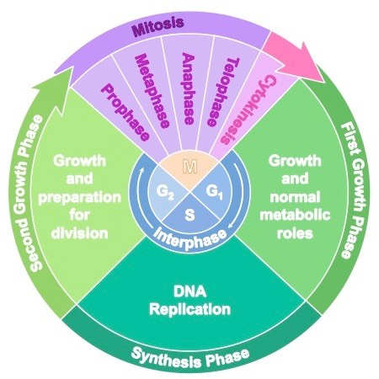
Why do single celled organisms’ cells divide?

Why do multicellular organisms’ cells divide?

Single celled organisms: reproduction
Asexual reproduction:
Mitosis vs. binary fission:

Examples:

Multicellular organisms: growth and repair
Somatic cells:

Gametes:

Do different cells divide differently?

Apoptosis=

What controls cell division?

What happens if it all goes wrong?

Cell division control:

Lost with mutations or damage to the DNA

Cancer=

Benign vs. malignant:

