NAME:________________________________________ PER:_________ DATE:________________ SCORE_____________
BIOLOGY INDEPENDENT PRACTICE (L.16.4 – mitosis) – 10 POINTS

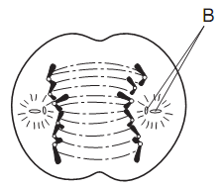
- The cell in the diagram to the right illustrates a stage of mitotic cell division.
A
Label the parts of the cell that each letter represent.

A.
B.
C.
C

True or False. If false, indicate the part of the statement that is incorrect and write a sentence explaining why it is incorrect.

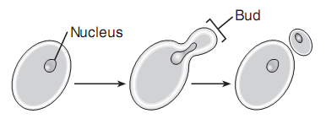
- Yeasts are organisms that use budding to reproduce. Researchers have used it to gather information about the biology of the eukaryotic cell and ultimately human biology. Yeast produce offspring that usually have genes that are half of the genetic information of the parent.

True or False _______________________________________ True or False ______________________________________

____________________________________________________________________________________________________

____________________________________________________________________________________________________

____________________________________________________________________________________________________

____________________________________________________________________________________________________

- Binary Fission is the only form of reproduction in certain bacteria. Bacteria must synthesize their DNA quickly before they are destroyed. Many different circumstances may not allow for the synthesis of DNA to occur. Bacteria that use binary fission produce offspring that are genetically similar, but slightly different in order to become stronger through evolution.

True or False ________________________________________________________________________________________

____________________________________________________________________________________________________

____________________________________________________________________________________________________
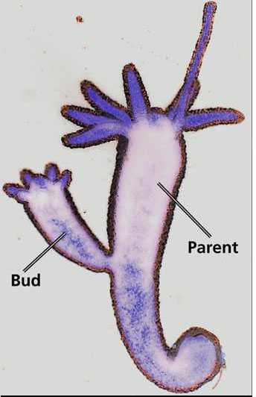
- The picture to the right shows Binary Fission. A process in which a parent produces offspring with
half of the genetic code.

True or False ________________________________________________________________________________________

____________________________________________________________________________________________________

____________________________________________________________________________________________________

- Cloning in biology is the process of producing similar populations of genetically identical individuals that occurs in nature when organisms such as bacteria, insects or plants reproduce asexually. A cloned sheep has a diploid chromosome number of 50. The diploid chromosome number of the sheep cell that was used to produce the cloned animal is 25.

True or False ________________________________________________________________________________________

____________________________________________________________________________________________________

____________________________________________________________________________________________________

- A cloned pig has a diploid chromosome number of 36. The diploid chromosome number of the pig cell that was used to produce the cloned animal is 36.

True or False ________________________________________________________________________________________

____________________________________________________________________________________________________

____________________________________________________________________________________________________

- Draw a diagram of the cell cycle (Interphase, Mitosis, Cytokinesis; 6 circles) in the correct order using all of the phases. Make sure to include centrioles, spindle fibers, and the correct positioning of the chromosomes.

8. Looking at the diagram to the right, explain the activities in each phase.
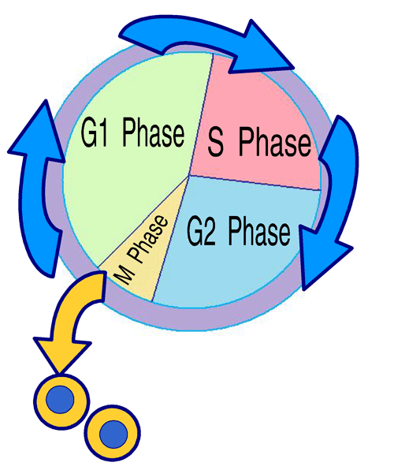
Phase | Explanation
G1 Phase
S Phase
G2 Phase
M Phase

