Why do all of us look different?

Key Points:
- Meiosis is a process of cell division used to create sex cells
- Meiosis makes four daughter cells from one parent cell
- The cells at the end of meiosis have half the number of chromosomes as the original
- In meiosis, the chromosomes in the new cells are genetically different

Why meiosis?

Haploid vs. Diploid

What does meiosis make?

Homologous pairs:
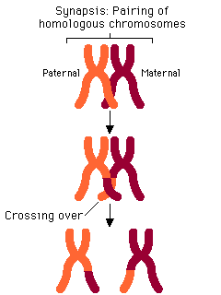

Crossing over:

Genetic variation:

Steps of Meiosis:

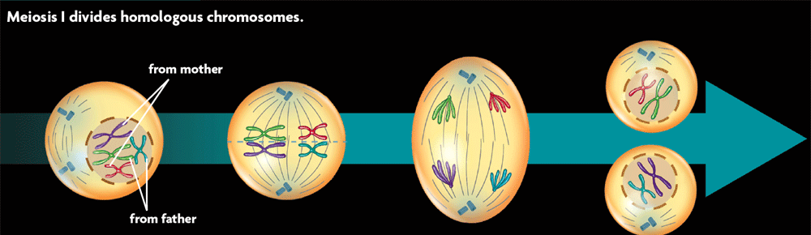

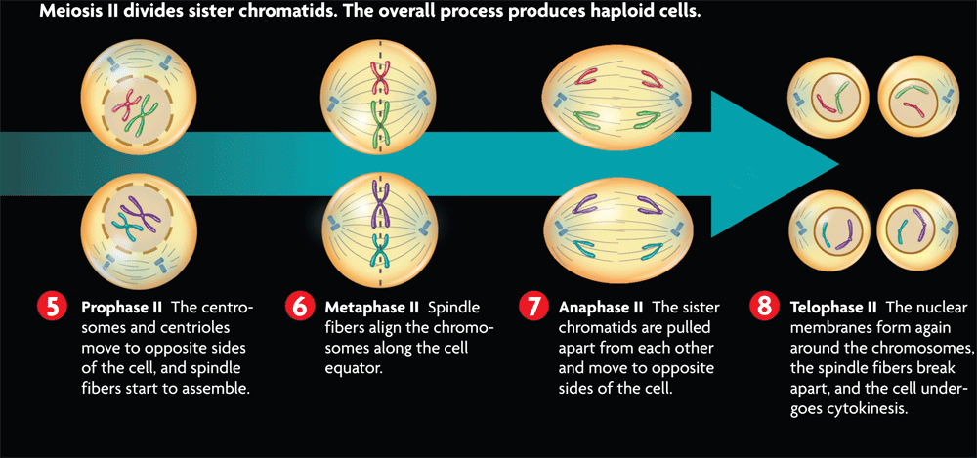

What’s a zygote?

Law of Independent Assortment:

Crossing over and the law of independent assortment increase genetic variation in a population.

