Fetal Development Guided Notes
Key concept: Development progresses in stages from zygote to fetus.
The fertilized egg implants into the uterus and is nourished by the placenta and umbilical cord.
The _______________ becomes a ____________________ and implants in the uterus.
- ________________ develops into __________ and nervous system
- mesoderm develops into Internal tissues and ____________
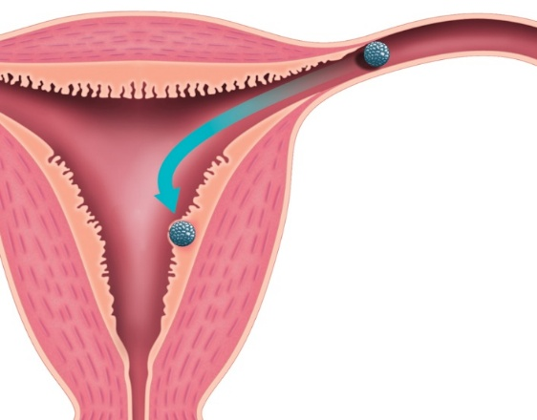
- ________________ develops into ____________________ organs and their lining
blastocyst
uterine wall
Implantation of blastocyst

- The blastocyst becomes an ________________.
- Embryonic membranes protect and nourish the embryo.
  - __________________________ cushions embryo.
  - __________________ connects mother and embryo.
  - _______________________________ connects embryo to placenta.
A zygote develops into a fully formed fetus in about 38 weeks.
- Human pregnancies are divided into ________________________.
  - __________ trimester: body plan and early development
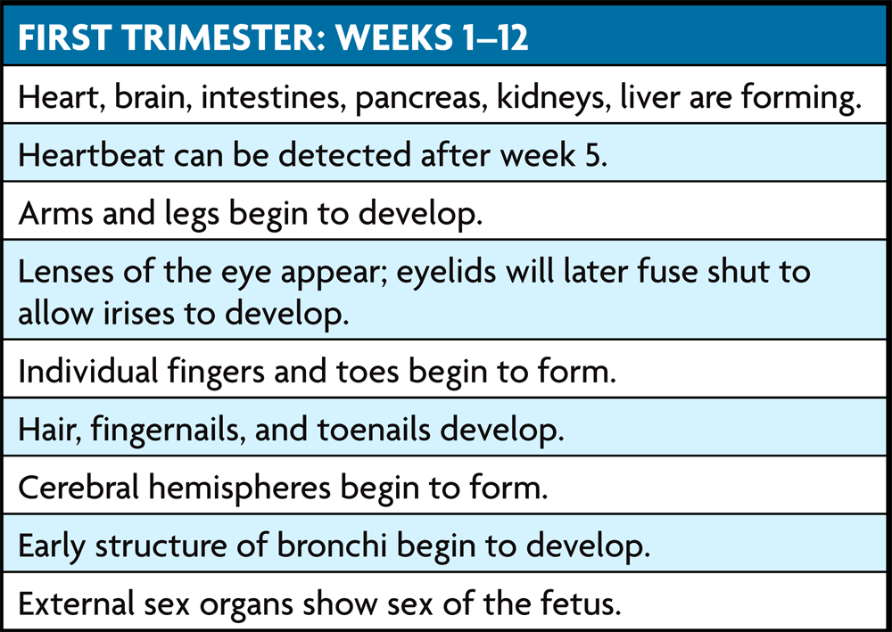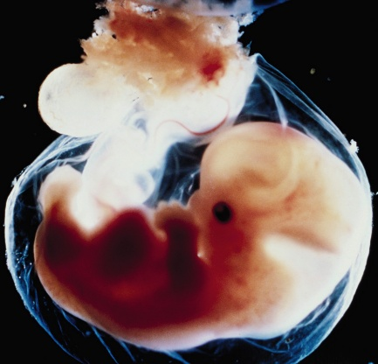
______________ trimester: fetus more active, developed
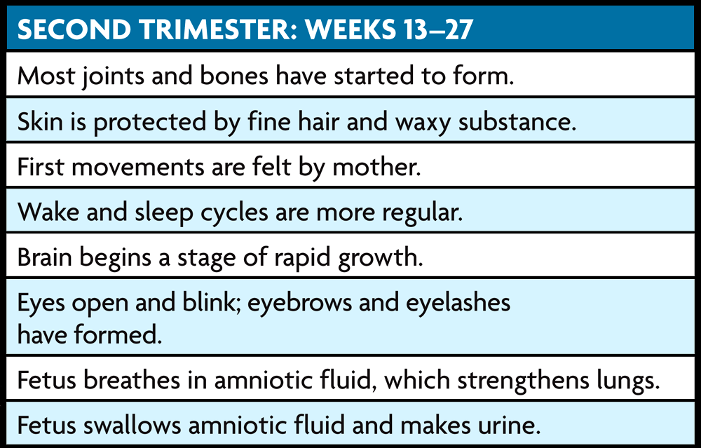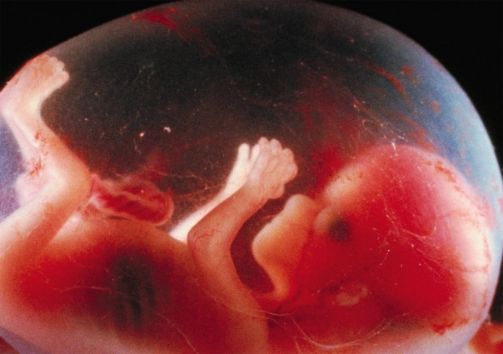
____________ trimester: all organs fully formed
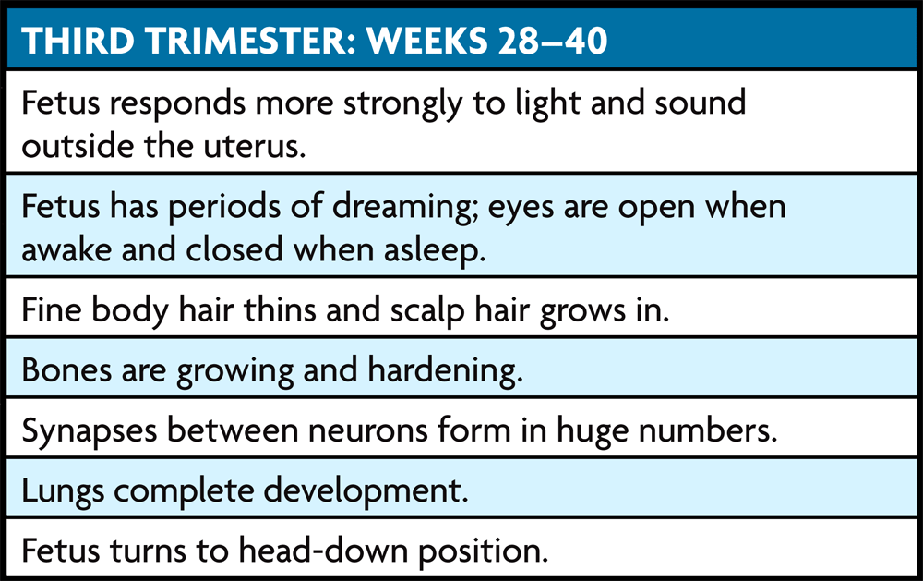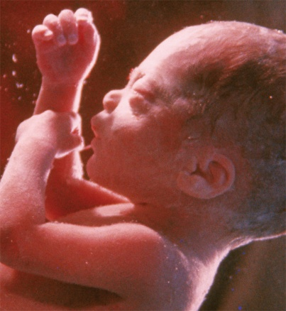

The mother affects the ____________, and pregnancy affects the ______________.
- The fetus depends on the ________________ for all its _____________________.
  - mother's diet must support ________________________
  - mother must avoid ____________ chemicals
- The mother’s health is affected by pregnancy in a number of ways.
  - increase in _________________ and body weight
  - pregnancy ________________ affecting homeostasis
  - regular medical __________________ needed

