Reproductive System Card Activity
Adapted from Human Reproduction Lesson on CPalms
http://www.cpalms.org/Public/PreviewResourceLesson/Preview/28126

Teacher Instructions
Lab Set up:
- Print a class set of cards on cardstock.
- Cut the cards with the questions attached.
- The cards can be folded with the questions behind the diagram or left with the diagram beside the question.

During the Lab
- Handout one card to each student or student pairs.
- Have the students answer the cards alone on a separate sheet of paper. Provide students with a set time limit to complete the task. (Use of a timer is optional) Teacher discretion to allow students to use a textbook, notes or other resource.
- Have the students separate by male reproductive cards on one side of the room and female reproductive system on the other side.
- Have like # numbered cards become groups and discuss their answers. (3-4 minutes)
- Break into groups again - (depending on class size)
Group #1 – contains cards 1, 2, 3 and 4
Group #2 – contains cards 5, 6, and 7.
Group #3– contains cards 1, 2, 3 and 4
Group#4-– contains cards 5, 6, and 7
- Students should share their questions and responses with the group.
- Select groups to present their answers to the class. Be sure to correct mistakes, and provide feedback to responses

Optional Assessment - Teacher can choose the concept map or the ticket out the door.
Concept Map: http://www.classzone.com/cz/books/bio_12_fl/resources/htmls/interactive_review/bio_intrev.html
Section #1 Male and Female Reproductive System
Ticket out the Door:
Trace the path of sperm through the male reproductive system.
Teacher Instructions- Students can draw the pathway that sperm travel on paper, or Students can write a very short story of how sperm moves from the testes to Epididymis, vas deferens, and the urethra.

Reproductive System Anatomy Cards
1 | Questions  1. What is the function of Part A?  2. What is the function of Part B?  3. How is homeostasis maintained by Part A?
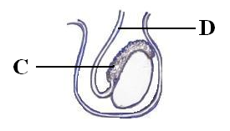  2 | Questions  - What is the function of Part C?  - What is the function of Part D?  - List the structures that the sperm passed through to get to Part D.
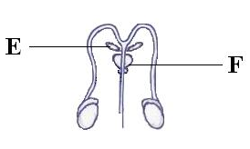  3 | Questions  - What is produced in Part E?  - What is produced in Part F?  - Explain why these substances are necessary for sperm to survive.
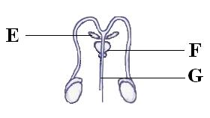  4 | Questions  10. What substances pass through Part G?  11. What are the two functions of Part G?
5 | Questions  12. What is produced in Part H?  13. What is function of Part I?  14. Which process can occur in Part I?
6 | Questions  14. What is the function of Part J?  15. What is Part K?  16. What is the function of Part K?
7 | Questions  16. What is Part J‘s role in the female reproductive system?  17. How does Part L assist in reproduction?

