Cell Theory Review Sheet
SC.912.L.14.1: Describe the scientific theory of cells (cell theory) and relate the history of its discovery to the process of science.
In Biology, the cell theory is a scientific theory that describes the properties of cells, the basic unit of structure in every living thing. The initial development of the theory, during the mid-17th century, was made possible by advances in microscopy, the study of cells is called cell biology. Cell theory is one of the foundations of biology.
The three parts to the cell theory are as described below:
1. All living things are made of one or more cells.
2. Cells are the basic units of structure and function in organisms
3. All cells arise from existing cells.
Like many theories, the cell theory did not develop overnight and was not created by one scientists. The cell theory is a work in progress and many scientists have contributed to its development. Below is a timeline of important scientists and their contribution to the cell theory.
Year | Scientist | Contribution
1595 | Zacharias Jensen | Jensen created the first compound microscope.
1655 | Robert Hooke | Hooke, using a microscope that he devised, viewed the cell walls of cork for the first time. He coined the term “cell” still used in Biology today.
1670 | Antonie van Leeuwenhoek | Van Leeuwenhoek observes the first living cells in pond water using lenses that he created for his first microscope. He called these organisms animalcules (now called protists)
1838 | Marrhias Jakob Schleiden | Schleiden proposes that all plant tissues are composed of cells.
1839 | Theodor Schwann | Schwann concludes that not just plant tissue, but animal tissues, as well, are composed of one or more cells. He also states that the cell is the basic unit for all organisms.
1855 | Rudolf Virchow | Virchow adds the third part to the cell theory stating that cells only come from other living cells.

For each part of the cell theory explain which scientist contirbute to it and how they contributed to that particular part of the theory.
Cell Theory Part | Contributing scientist and how did they aid in the development of the cell theory part.
- All living things are made of one or more cells.
- Cells are the basic units of structure and function in organisms

- All cells arise from existing cells.
- According to the cell theory, what is required for an object to be considered alive?

- How did improvements in the microscope help scientist form the cell theory?

- Use the appropriate phrases to complete the Venn Diagram comparing the terms ‘law’ and ‘theory.”
- Supported by large amount of data | - Based on hypotheses | - Can be modified
- Constantly changed as more information is gathered | - Used to make predictions. | - A summary of many experimental results and observations
- Can be reduced to mathematical equations | - Explains a wide range of observations and experimental results. | - Describe what nature does under certain characteristics.
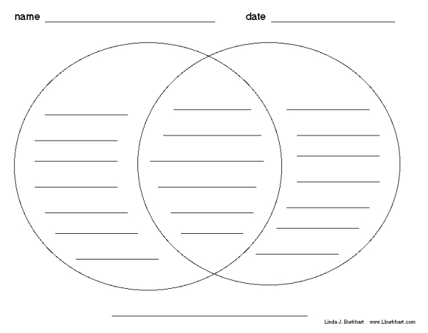

- A cheetah, like those shown below at left, and a paramecium, like the one shown below at right, are both living things.
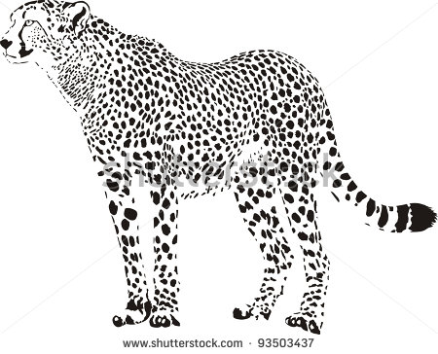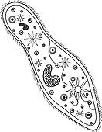
According to the cell theory, what can you conclude about these two very different organisms?
A. They are made of many cells.
B. They are made of one or more cells.
C. They come from the same kind of cell.
D. They come from non-cellular structures.

- In science, a theory is an explanation for some phenomenon that is based on observation, experimentation, and reasoning. One important theory in biology is the cell theory. What kinds of observations led to the development of the cell theory?
- testing of first vaccines
- discoveries of fossil bacteria
- isolations of DNA and RNA
- microscopic views of plants and animals

- Can the cell theory ever become a law? Why or why not?

- Cell theory was first proposed in 1838. Evidence obtained through additional scientific investigations resulted in the current cell theory. Which statement describes a component of the original cell theory that was removed because of the new scientific knowledge?
- All living things are made of cells.
- All cells come from other preexisting cells.
- Cells form through spontaneous generation.
- Cells are the basic structural and functional units of life.

- A scientist develops a hypothesis, designs an experiment, and obtains data that support her hypothesis. Which of the following best describes when a hypothesis becomes a theory?
A. When one good set of scientific data supports a theory
B. When the official scientific method is followed
C. When a website is created to display the theory
D. When it is supported by consistent data from many experimental trials

- The combined observations of Mattias Schleiden, Theodor Schwann and Rudolph Virchow resulted in the formation of the cell theory. Which of the following is not part of the cell theory?
- All cells contain a nucleus.
- All cells come from other living cells.
- All living organisms are made of one or more cells.
- Cells are the basic unit of structure and function of all living things.

