Properties of water Intro Experiments
SC.912.L.18.12 Discuss the special properties of water that contribute to Earth's suitability as an environment for life: cohesive behavior, ability to moderate temperature, expansion upon freezing, and versatility as a solvent.

#1. Surface Tension experiment – Part 1
Water is a polar molecule. This characteristic makes the water molecules stick together with a very strong bond. The surface of the water bulges upward with each drop of water, until the molecules can no longer stick together at the top of the glass. This “bulging” is called surface tension.
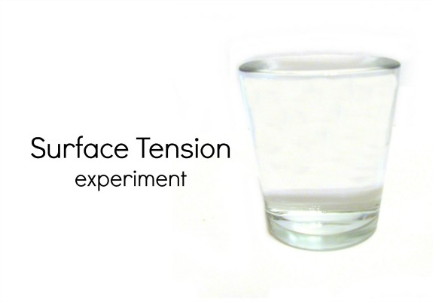
Materials
- glass
- measuring cup filled with water
- eyedropper

Procedure:
- Pour water into the glass, filling it to the brim.
- With the eyedropper, carefully add additional water to the glass.
- Continue to add water until it over flows.
- Observe the surface of the water and watch it bulge above the top of the glass.

#2. Surface Tension Experiment – Part 2
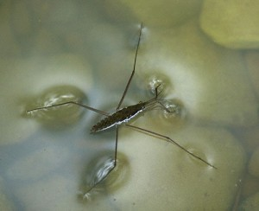
Surface tension is one of water's most important properties. It is the reason that water collects in drops, but it is also why water can travel up a plant stem, or get to your cells through the smallest blood vessels. You can experiment with surface tension using just a few household items.
Materials
- Plastic cup
- Paper clip
- Water
- Dish detergent
Procedures:
- Start with a cup of water and some paper clips. Do you think a paper clip will float in the water? Drop one in the cup to find out. Since the paper clip is denser than the water, it will sink to the bottom of the cup.
- Now find out if you can use surface tension to float the paper clip. Instead of dropping the paper clip into the cup, gently lay it flat on the surface of the water. (This is tricky — it may help to place a piece of paper towel slightly bigger than the paper clip in the water. Then lay the paper clip on top of it. In a minute or so, the paper towel will sink, leaving the paper clip floating on top of the water.) Even though the paper clip is still denser than the water, the strong attraction between the water molecules on the surface forms a type of “skin” that supports the clip.
- Now put a drop of dish soap in the water. This drop will bind with the water molecules, interfering with the surface tension. The paper clip will sink. You can try floating other things on top of the water also - pepper floats well until you add dish soap. Can you find any other light items that will float?

#3. Cohesive and Adhesive Behavior of Water
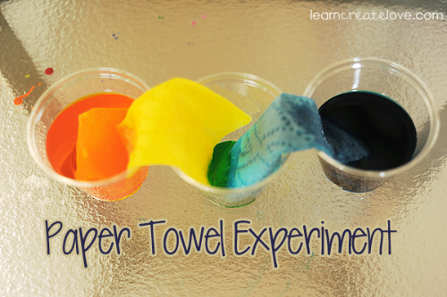
Materials
- 3 clear cups
- Enough water to fill 2 of the cups
- Food coloring
- Spoon to stir
- Paper towels

Procedures
- Fill 2 cups ½ full with water.
- Add food coloring to each one and stir.
- Roll a paper towel into a tight tube.
- Stick one end into one of the colored waters, and the other end into the empty middle cup.
- Repeat for the other side, so that each cup has a paper towel that ends up in the middle cup, as seen above.
- Observe the water moving up the paper towel. Complete another station, and then come back to check on the experiment.

#4 Bending Water
Materials
- Water faucet with running water
- Latex balloon
- Small piece of wool (optional)

Procedures
- Inflate the balloon.
- Turn on the faucet so that the water is coming out at a slow and steady stream.
- Take the inflated balloon and rub it against the piece of wool or your hair to create a static charge.
- Slowly and carefully place the balloon next to the stream of water. Record your observations.

#5 High Specific Heat
The high heat capacity of water explains why the temperatures of land near a body of water are more moderate. The high heat capacity of water keeps its temperature within a relatively narrow range, causing nearby coastal areas to also have a narrow daily and seasonal temperature range. In contrast, areas with similar weather conditions that are farther from the coast tend to have a much wider range of seasonal and daily temperatures. To summarize, large bodies of water tend to moderate the temperature of nearby land due to the high heat capacity of water. This high heat capacity results from both the higher specific heat of water and the mixing of heat throughout a greater depth over oceans.

Materials
- Two glass beakers (label A and B)
- Two thermometers
- 50 mL of water
- Hot plate
- Sand
- Stopwatch or clock with a second hand

Procedure
- Add 50 mL of tap water to beaker “A” and 50 mL of sand to “B”.
- Heat both beakers to 30° C. Hold a thermometer in the middle of each beaker and do not allow it to touch the bottom. You may gently stir the water.
- Take the beakers off as they reach 30° and then time how long it takes them to cool to 25° C. One student in the group needs to be responsible to time each beaker as it cools.
- Write down your data on your student sheet.

#6 Amazing Water Race & Water Stretch
Materials
- Water maze
- Toothpick
- Pipette or eyedropper
- Tape
- Wax paper

Procedure
Amazing Water Race
- Tape a piece of wax paper on top of the maze.
- Place a water drop small enough to fit inside the circle on your paper.
- Move the water drop through the maze with a toothpick. If the drop separates, go back and collect it before continuing.
- Time how long it takes to move the drop through the maze.

Water Stretch
- Predict how far you can stretch the drop of water.
- Try it out! Place one drop of water in the circle.
- Try to stretch the water droplet as far as you can.
- Find the difference between the prediction and the actual length.

