Hominid Evolution Review Sheet
SC.912.L.15.10 Identify basic trends in hominid evolution from early ancestors six million years ago to modern humans, including brain size, jaw size, language, and manufacture of tools.
A primate is a member of the mammalian order Primates. Hominids are primates that walk upright on two legs, flexible hands and feet, forward looking eyes, and enlarged brains relative to their body size. Hominids are members of the group that led to the evolution of humans. Hominids walk upright, have long lower limbs, opposable thumbs, and relative large brains. According to the fossil record, hominids first appeared on Earth about 5 million to 7 million years ago. The early hominids best represented by fossil finds belong to the group known as australopithecines.
Australopithecines belong to the genus Australopithecus. Their brains were generally as large as those of modern chimpanzees. They were much smaller, however, than the brains of modern humans. Our genus, Homo, is composed of at least three species. The first members of the genus Homo appeared on Earth more than 2 million years ago. In the early 1960s, stone tools were discovered near hominid bones. Because of its association with tools, this hominid was named Homo habilis. The Latin word homo means ―man,‖ and the Latin word habilis means ―handy.‖ Fossils indicated that Homo habilis lived in Africa for about 500,000 years and then became extinct.
The species that replaced Homo habilis is called Homo erectus. Homo erectus was larger than Homo habilis and also had a large brain. This species evolved in Africa and migrated into Asia and Europe. Homo erectus survived for more than 1 million years. The species disappeared about 200,000 years ago, as early modern humans emerged. Most scientists think that Homo erectus was the direct ancestor of our species, Homo sapiens. Of the three modern humans, Homo sapiens is the only surviving species of the genus Homo. The name Homo sapiens is from the Latin homo, meaning ―man,‖ and sapiens, meaning ―wise.‖ Early Homo sapiens left behind many fossils and artifacts, including the first known paintings.

SC.912.L.14.26 Identify the major parts of the brain on diagrams or models.
Major Parts of the Brain: The Cerebrum
The cerebrum has four sections or lobes:
- Frontal lobe – located under the forehead
- Temporal lobe – under the side of the face
- Occipital lobe – under the back of the head
- Parietal lobe – between the frontal and occipital lobe
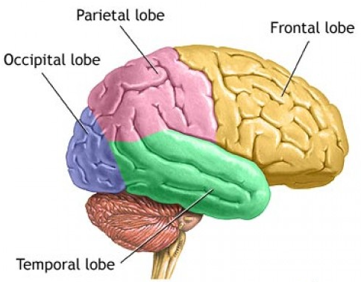
The Cerebellum is located at the base of the brain.
The brain stem connects the upper and central parts of the brain to the spinal cord. It has three parts, including the middle (pons) and the lowest sections (medulla oblongata).
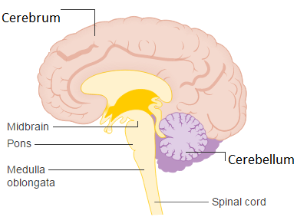

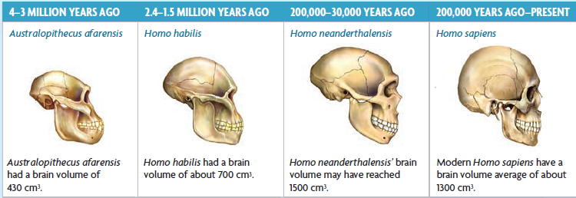
- What characteristic besides brain size differ among the species shown?

- Consider the skull illustrations above. Besides size, how did skull structure change as hominids evolved? What features are considered more apelike than humanlike?

- When might having an increasingly larger brain size no longer be a selective advantage?

- How might an increase in brain size help the development of tools, language and culture?

- What characteristics shared by humans and other primates suggest they have a common ancestor?

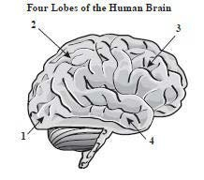
- The illustration to the right shows four lobes of the human brain. What lobe is designated by label 2?
- temporal
- parietal
- occipital
- frontal
- Scientists have found evidence that about 2.4 million years ago a gene regulating jaw muscles mutated and may have led to the more graceful human jaw we see today. The diagram below shows the skulls of 3 hominid species.
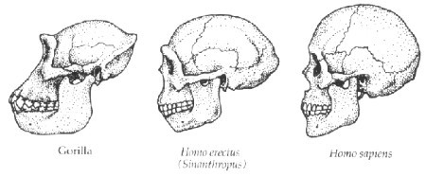
Which statement below most closely explains the link between jaw size and hominid evolution?
- The jaws of hominids evolved to be smaller and less protruding over time.
- The jaws of hominids evolved to be larger and more protruding over time.
- There appears to be no change in the jaws of hominids over time.
- The jaws of hominids changed over time due to a change in brain size.

- Paleontologists have compared modern human skeletons to fossils of hominids called Australopithecines from two to five million years ago, before the appearance of modern humans. They found that although Australopithecines were similar to chimpanzees, certain features like the shape of their hips and spine supported upright walking, similar to the modern human skeletal structure. Which of the following best describes why the discoveries of the Australopithecine fossils are important for understanding modern human evolution?
- They are evidence of transitional species that show how modern humans evolved from ape like ancestors.
- They are important for understanding how modern pelvic bone are necessary for upright walking.
- They provide evidence that modern humans and chimpanzees are not related by a common ancestor.
- They show that modern humans had to compete with other upright bipedal hominids for food and resources.

