Human Reproduction Review Sheet
SC.912.L.16.13 Describe the basic anatomy and physiology of the human reproductive system. Describe the process of human development from fertilization to birth and major changes that occur in each trimester of pregnancy.
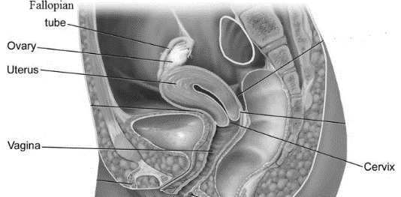
The female reproductive system Male reproductive system

The main features of the female reproductive system:
Vagina: Provides a passageway for the fetus to be expelled from the uterus
Uterus: Receives fertilized egg or sheds superficial layer if fertilization does not take place — menstruation. Contains the fetus during pregnancy.
Fallopian tubes: To transport the egg from the ovary to the uterus.
Ovaries: To produce ova. Hormone production.
Cervix: The opening to the uterus
The main features of the male reproductive system:
Penis: Carries urine and seminal fluid to outside the body
Scrotum: Encloses and protects the testes
Testes: Produce and secrete sperm and testosterone.
Vas deferens: Tubes that carry sperm from the testes to the urethra.
Epididymis: The coiled tubes behind the testicles where sperm mature and are stored.
Seminal Vesicle: Glands on each of the vas deferens that produce fluids that mix with the sperm to make semen.
Prostate Gland: A gland under the bladder that contains pleasure sensors and produces fluids that mix with sperm to make semen.
Urethra: A tube that can carry sperm and urine out of the body.
Reproduction:
Provided all organs are present, normally constructed, and functioning properly, the essential features of human reproduction are (1) release of an ovum, or egg, at a specific time in the reproductive cycle, (2) internal fertilization of the ovum by or sperm cells, (3) transport of the fertilized ovum to the uterus, or womb, (4) implantation of the blastocyst, the early embryo developed from the fertilized ovum, in the wall of the uterus, (5) formation of a placenta and maintenance of the unborn child during the entire period of pregnancy.
Fetal development: First Trimester
- heart is beating
- all major body systems continue to develop and function, including the circulatory, nervous, digestive, and urinary systems
- the mouth is developing tooth buds (which will become baby teeth)
- the fingers and toes are still webbed/fingernails and toenails appear
- the bones begin to develop
- After 8 weeks, the embryo is now referred to as a fetus
- All major organs, systems and eyelids are formed
The Second Trimester
- The fetus kicks, moves, and can turn from side to side.
- Eyes move to the front of the face and ears move to sides of the head.
- Fetus develops reflexes, can respond to certain stimuli and can hear.
- The brain will undergo its most important period of growth
- Nails have grown on fingers/toes, and fingers/toes are fully separated.
- The fetus goes through cycles of sleep and wakefulness.
- Skin is wrinkly/covered with soft hair (lanugo), hairgrows on head.
- Fat begins to form on the fetus.
- Eyelids are beginning to open and the eyebrows/ eyelashes are visible.
- Fingerprints and toe prints have formed.
The Third Trimester
The fetus continues to grow in size and weight. The lungs are still maturing. Fetal development during the third trimester includes:
- The fetus can see and brain continues to develop.
- The bones of the skull remain soft.
- By 38 to 40 weeks, the lungs have matured completely.
- Describe the fertilization process:

- In which trimester is the baby the most developed?

- During which trimester does the brain develop the most?

- A fertilized egg undergoes several stages before it is successfully implanted. The diagram below shows these stages as the fertilized egg travels through the female reproductive system.
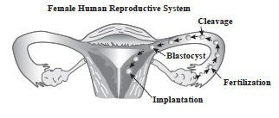
In which of the following structures of the female human reproductive system is the blastocyst implanted during normal human development?
A. ovary
B. uterus
C. vagina
D. amniotic sac

- The drinking of alcoholic beverages by a pregnant woman is harmful to the development of her fetus. This is most damaging early in a pregnancy because during this time
A. the lungs of the fetus become functional.
B. alcohol can easily enter the mouth of the fetus.
C. many of the essential organs of the fetus are forming.
D. the fetus cannot excrete wastes.

- Sperm are created through meiosis in an area of the testes called the seminiferous tubules. Through which structure do the sperm travel to exit the testes?
A. vas deferens
B. seminiferous tubules
C. scrotoum
D. epididymis

- Which of the following is true of a zygote?
A. It forms into a blastocyst
B. It is an unfertilized egg
C. It produces haploid male gametophytes
D. It is made up of only one cell

- Which of the following describes fertilization?
A. cell differentiation to form a blastula
B. formation of germ layers in a deuterostome
C. a sperm joining an egg to form a zygote
D. sperm and egg production

- Below is a diagram of the male reproductive system.
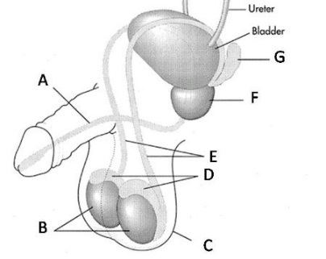
Which structure is represented by the letter D?
A. scrotum
B. testes
C. prostate gland
D. epididymus

- Abnormalities present in the cells that line the uterus may prevent the production of offspring by directly interfering with which process?
A. the development of the embryo
B. the differentiation of gametes into zygotes
C. the secretion of estrogen by the ovary
D. the production and release of egg cells

- What is the human embryo called after the eighth week of development?
A. a zygote
B. an infant
C. a fetus
D. a morula

