**Immune System Review Sheet**

**SC.912.L.14.52 Explain the basic functions of the human immune response, vaccines, and antibiotics.**

The human immune system has two levels of immunity: specific and non-specific immunity. Through **non-specific immunity**, also called innate immunity, the human body protects itself against foreign material that is perceived to be harmful. Microbes as small as viruses and bacteria can be attacked, as can larger organisms such as worms. Collectively, these organisms are called **pathogens** when they cause disease in the host. All animals have innate immune defenses against common pathogens. These first lines of defense include outer barriers like the skin and mucous membranes. When pathogens breach the outer barriers, for example through a cut in the skin or when inhaled into the lungs, they can cause serious harm. Some **white blood** cells (**phagocytes**) fight pathogens that make it past outer defenses. A phagocyte surrounds a pathogen, takes it in, and neutralizes it.

While healthy phagocytes are critical to good health, they are unable to address certain infectious threats. **Specific immunity** is a complement to the function of phagocytes and other elements of the innate immune system. In contrast to innate immunity, specific immunity allows for a targeted response against a specific pathogen. Only vertebrates have specific immune responses.

Two types of white blood cells called lymphocytes are vital to the specific immune response. They produced in the bone marrow, and mature into one of several subtypes. The two most common are **T cells** and **B cells.** An **antigen** is a foreign material that triggers a response from T and B cells. The human body has B and T cells specific to millions of different antigens. B cells can mature and differentiate into plasma cells that produce a protein called an **antibody**. This protein is specifically targeted to a particular antigen. B cells rely on T cells to provide a signal that they should begin the process of maturation. When a properly informed B cell recognizes the antigen it is coded to respond to, it divides and produces many plasma cells. The plasma cells then secrete large numbers of antibodies, which fight specific antigens circulating in the blood.

The body produces another line of defense against viruses: **interferon**, a chemical substance produced by white cells that interferes with the growth of a virus and inhibits the viruses' ability to infect cells. Unlike antibodies, interferon works against all viruses, not just one.

There are two kinds of immunity: active and passive. In **active immunity**, the body develops its own resistance to disease. For example, once you've had measles your body develops a lifelong immunity to the disease. In **passive immunity**, resistance to disease initially comes from an external source. Infants who are breast fed carry passive immunity to certain diseases because they receive the protective antibodies from their mother's milk. This immunity usually lasts only about as long as the mother breast feeds.

Infection occurs when a pathogen invades body cells and reproduces. Infection will usually lead to an immune response. If the response is quick and effective, the infection will be eliminated or contained so quickly that the disease will not occur. Sometimes infection leads to disease. Disease can occur when immunity is low or impaired, when its ability to damage host cells is high, and when the number of pathogens in the body is great.

Depending on the infectious disease, symptoms can vary greatly. **Fever** is a common response to infection: a higher body temperature can heighten the immune response and provide a hostile environment for pathogens. **Inflammation**, or swelling caused by an increase in fluid in the infected area, is a sign that white blood cells are on the attack and releasing substances involved in the immune response.

**Vaccination** works to stimulate a specific immune response that will create memory B and T cells specific to a certain pathogen. These memory cells persist in the body and can lead to a quick and effective response should the body encounter the pathogen again.

An **antibiotic** is given for the treatment of an infection caused by bacteria. Antibiotics target microorganisms such as bacteria, fungi and parasites. However, they are not effective against viruses.

Explain how the immune system may respond to each situation.

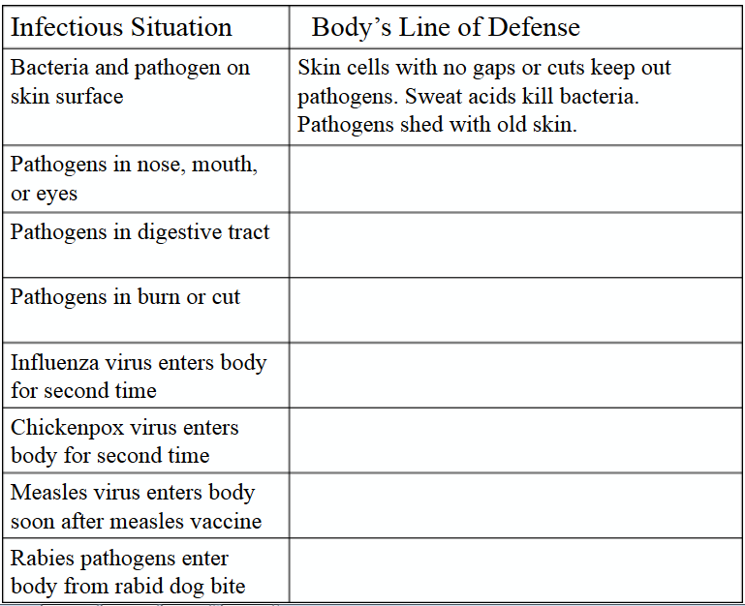

1. Lots of weird things like hair and mucous help protect your body. In particular, the skin is our first defense against germs! Why is the skin a good defense mechanism for the immune system?
2. The common cold, most often caused by the rhinovirus, causes fever, sore throat, coughing, and nasal congestion. Why is treatment with antibiotics not recommended for the common cold?
   1. They are only effective in treating fever.
   2. They are ineffective against viral infections.
   3. They increase the susceptibility to future colds.
   4. They require a dosage that most people would not tolerate.
3. The diagram below represents an event that occurs in the blood.



Which statement best describes this event?

* 1. Cell A is a white blood cell releasing antigens to destroy bacteria.
  2. Cell A is a cancer cell produced by the immune system and it is helping to prevent disease.
  3. Cell A is a white blood cell engulfing disease causing organisms.
  4. Cell A is protecting bacteria so they can reproduce without being destroyed by predators

1. Herd immunity occurs when a high enough percentage of a population becomes protected against a disease so that the disease cannot spread in that population. Which of the following is the best example of herd immunity?
   1. A school reduces the number of colds in children by encouraging frequent hand-washing
   2. Polio is unknown in the Americas today because most children receive polio vaccines
   3. Employees at a company are encouraged to get flu shots to avoid becoming sick and missing work
   4. A county sprays trees to kill mosquitoes in order to prevent people from becoming sick after being bitten