Macromolecules Review Sheet
SC.912.L.18.1: Describe the basic molecular structures and primary functions of the four major categories of biological macromolecules.

Four principal classes of organic compounds are found in living things: carbohydrates, lipids, proteins, and nucleic acids.
Carbohydrates are organic compounds made of carbon, hydrogen, and oxygen atoms in the proportion of 1:2:1. Carbohydrates are a key source of energy, and they are found in most foods. The building blocks of carbohydrates are single sugars, called monosaccharides, such as glucose, C6H12O6, and fructose. Disaccharides are double sugars formed when two monosaccharides are joined. For example, sucrose, or common table sugar, consists of both glucose and fructose. Polysaccharides such as starch are chains of three or more monosaccharides. Starch and cellulose, which are found in plants, and glycogen, which is made by animals, are examples of polysaccharides.

Lipids are nonpolar molecules that are not soluble or mostly insoluble in water. They include fats, phospholipids, steroids, and waxes. Phospholipids make up the lipid bilayer of cell membranes. Steroids include cholesterol, which is found in animal cell membranes. Other lipids include some light-absorbing compounds, such as the plant pigment chlorophyll. Fats are lipids that store energy.

Proteins are usually large molecules formed by linked smaller molecules called amino acids. Amino acids are the building blocks of proteins. Twenty different amino acids are found in proteins. Some amino acids are polar, and others are nonpolar. Some amino acids are electrically charged, and others are not charged. Proteins fold into compact shapes, determined in part by how the protein’s amino acids interact with water and one another. Some proteins are enzymes and promote chemical reactions. Other proteins have important structural functions. Other proteins called antibodies help your body defend against infection. Specialized proteins in muscles enable your muscles to contract. In your blood, a protein called hemoglobin carries oxygen from your lungs to body tissues.

Nucleic acids are long chains of smaller molecules called nucleotides. A nucleotide has three parts: a sugar, a base, and a phosphate group, which contains phosphorus and oxygen atoms. There are two types of nucleic acids—DNA and RNA—and each type contains four kinds of nucleotides. DNA, or deoxyribonucleic acid, consists of two strands of nucleotides that spiral around each other. Chromosomes contain long strands of DNA, which stores hereditary information. RNA, or ribonucleic acid, may consist of a single strand of nucleotides or of based-paired nucleotides. RNA plays many key roles in the manufacture of proteins.

- What is the relationship between a monomer and a polymer? How do they relate to macromolecules?

- Complete the following chart for the four principal Macromolecules: 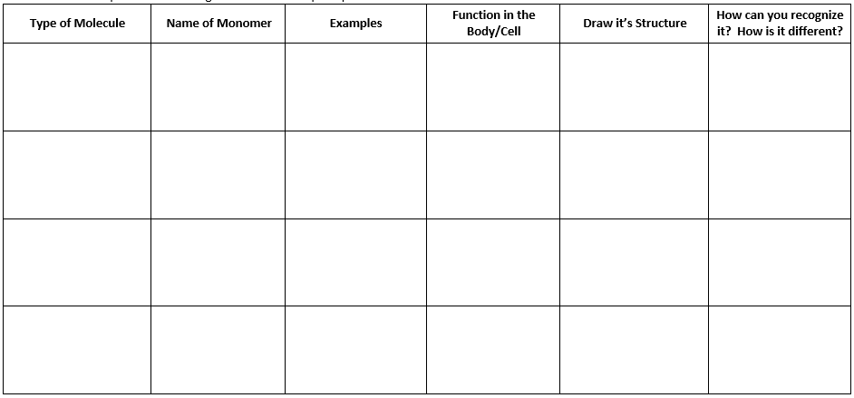
- Two of the four principle classes of organic compounds are proteins and nucleic acids. What is the relationship between proteins and nucleic acids?
- nucleic acids use proteins for energy
- nucleic acids are a subset of proteins
- proteins are long polymers of nucleic acids.
- nucleic acids contain the information to make proteins

- The diagram below shows the general structure of an amino acid. Which type of molecule is formed from amino acids?
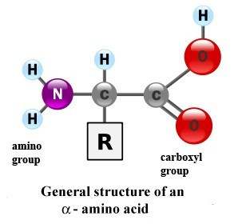

- lipids
- proteins
- carbohydrates
- nucleic acids

- You are analyzing a compound in the laboratory. You find that it is made up of carbon, hydrogen, and oxygen in a ratio of two hydrogen atoms for each carbon atom. How will you classify the compound?
- lipid
- protein
- carbohydrate
- nucleic acid

- Fats, oils and cholesterol are all types of what?
- cell membranes
- hormones
- lipids
- fatty acids

- RNA and DNA are which type of macromolecules?
- carbohydrate
- lipid
- nucleic acid
- protein

