**SC.912.L.16.1 Use Mendel’s laws of segregation and independent assortment to analyze patterns of inheritance**

**SC.912.L.16.1 Discuss observed inheritance patterns caused by various modes of inheritance, including dominant, recessive, codominant, sex-linked, polygenic and multiple alleles.**

**Law of segregation** – inherits 2 copies of each gene, one from each parent; gives only one copy of each gene to gametes; traits are inherited and persist over generations

**Homozygous** – alleles are alike (RR, rr)

**Heterozygous** – alleles are different (Rr)

**Genotype** - genetic make-up (alleles) Tt

**Phenotype** – physical characteristics (tall plant)

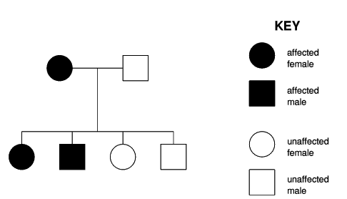**Dominant** – expressed, can be homozygous or heterozygous (TT or Tt)

**Recessive** –only expressed if both alleles are recessive (tt = short plant)

|  |  |
| --- | --- |
|  |  |
|  |  |

|  |  |  |  |
| --- | --- | --- | --- |
|  |  |  |  |
|  |  |  |  |
|  |  |  |  |
|  |  |  |  |

**Punnett Squares** – Monohybrid or Dihybrid, parent F1, F2, FOIL method used in Dihybrid (16 squares)

Heterozygous x heterozygous in dihybrid cross will always give a 9:3:3 1 ratio

***Law of independent Assortment-*** Alleles pairs separate independently during gamete formation, different traits are inherited separately (Ex. all blonds do not have blue eyes)

**Sex-linked genes** –XX = female XY = male

* Carrier doesn’t have condition but can pass to offspring
* XXH = female carrier XHXH = female with condition
* XY = normal male XHY = male with condition

**Incomplete dominance** – neither allele dominates the other one (nothing is in control/charge)

Ex: a red flower x a white flower produces a PINK flower

**Codominance** – both alleles are expressed

Ex: flower with yellow and white petals (both traits are present)

**Eminent Chicken – black and white feather are present**

**Polygenic traits** – traits are produced by two or more genes

**Pedigree charts -** In these diagrams, people are represented by symbols, usually circles for female and squares for male, and the bottom line represents the children of the couple above. It is customary to use dark symbols to indicate someone affected with a genetic condition, and unfilled symbols for those who are unaffected. In the explanations that follow, an intermediate grey color is used to assist in understanding the effect of a heterozygote carrier.

**Genetic explanation**

Since the condition is shown in some of the first generation offspring but not in some others, this is not a simple cross between 2 different homozygotes. One parent must be heterozygous, and the allele for the condition must be dominant to the allele for absence of the condition. In this case the appearance of the condition is independent of the sex of the individual.

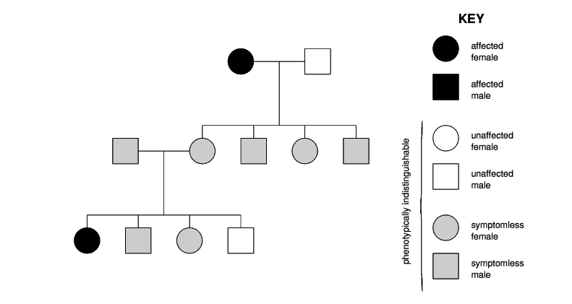**Genetic explanation**

Since the condition is not shown in any of the offspring in the first generation but it reappears in the second generation, it must be caused by a recessive allele. Once again, in this case the appearance of the condition is independent of the sex of the individual.

***Use a separate sheet of paper to show your work***

1. In cats, long hair is recessive to short hair. A true-breeding (homozygous) short-haired male is mated to a long-haired female.
   1. What is the genotype of the offspring?
   2. What percentage of the offspring will be homozygous dominant?
   3. How many of the off spring will have short hair?
2. Elizabeth is married to John, and they have four children. Elizabeth has a straight nose (recessive) and is able to roll her tongue (dominant). John is also able to roll his tongue, but he has a convex (Roman) nose (dominant). Of their four children, Ellen is just like her father, and Dan is just like his mother. The other children—Anne, who has a convex nose, and Peter, who has a straight nose—are unable to roll their tongues. Please answer the following questions about this family.
   1. What are the genotypes of Elizabeth and John?
   2. Elizabeth’s father was a straight-nosed roller, while her mother was a convex-nosed non-roller. What can you figure out about their genotypes?
   3. John’s father was a straight-nosed roller, while his mother was a convex-nosed roller. What can you determine about their genotypes?
3. In cats, there is a coat color gene located on the X chromosome. This gene is a different gene from the black/Siamese gene discussed in earlier problems. This gene has two alleles—orange and black. A heterozygous cat has tortoiseshell color (a splotchy mixture of orange and black). Predict the genotypic and phenotypic frequencies among the offspring of the following crosses. Pay careful attention to the genders of the offspring.
   1. Black female X Orange male
   2. Orange female X Black male
   3. Tortoiseshell female X Black male
   4. Tortoiseshell female X Orange male
4. It was suspected that two babies had been exchanged in a hospital. Mr. and Mrs. Jones received baby #1 and Mr. and Mrs. Simon received baby #2. Blood typing tests on the parents and the babies showed the following:

|  |  |
| --- | --- |
| Mr. Jones: Type A | Mr. Simon: Type AB |
| Mrs. Jones: Type O | Mrs. Simons: Type O |
| Baby #1: Type A | Baby #2 Type O |

NOTE: The ABO blood type gene has three alleles. IA and IB are codominant; i (for Type O) is recessive to both.

Were the babies switched? How do you know whether they were or they weren’t?

1. The table lists the trials for fruit color where allele R exhibits incomplete dominance over allele R'.

Heterozygous fruit have orange phenotypes. What percent of offspring are expected to have an orange phenotype if the parent plants are orange (RR') and yellow (R'R')?

a. 25% b. 50% c. 75% d. 100%

1. This diagram shows a pedigree for a recessive genetic disorder.



What is the genotype of individual 6?

* 1. XHXH
  2. XHXh
  3. XHY
  4. XhY