**SC.912.L.18.9 Explain the interrelated nature of photosynthesis and cellular respiration.**

**SC.912.L.18.7 Identify the reactants, products, and basic functions of photosynthesis.**

**SC.912.L.18.8 Identify the reactants, products, and basic functions of aerobic and anaerobic cellular respiration.**

**SC.912.L.18.10 Connect the role of adenosine triphosphate (ATP) to energy transfers within a cell.**

**Photosynthesis FACTS**

**Plants capture energy from sunlight and store it as chemical energy in the form of sugar – glucose**

One of the most important carbohydrates is glucose (C6H12O6). Glucose is called a monosaccharide because it forms one simple building block of more complicated carbohydrates. One structure of glucose is shown below

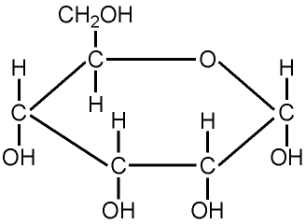

**Chloroplast** – organelle where photosynthesis takes place

**Equation:** 6CO2 +6H20 ----🡪 C6H1206 + 602

CO2 and H2O are reactants

O2 and C6H12O6 are products

**Chlorophyll** – light-absorbing molecule in chloroplast (pigment)

Organisms that make their own food are called **producers or autotrophs**

**Glucose and Oxygen produced in Photosynthesis are used for Cellular Respiration. They are the reactants for Cellular Respiration.**

**Cellular Respiration FACTS**

**Cellular Respiration releases energy by breaking down food molecules**

**Equation:** C6H1206 + 602 ----🡪 6CO2 +6H20

O2 and C6H12O6 are reactants

CO2 and H2O products

Oxygen and glucose are used to produce ATP – energy

Plant and animal cells make ATP using the process of cellular respiration

ATP (energy) released when a phosphate (P) is removed

ATP – high energy molecule

Takes place in the **mitochondria** which has lots of folds so there are more places for the reactions to occur

**Aerobic – needs oxygen Anaerobic – does NOT NEED Oxygen**

**SEQUENCE OF Cellular Respiration – Glycolyis (anaerobic) – Krebs (aerobic)**

**Glycolysis:** This process happens with anaerobic and aerobic reactions.

Takes place in the cell cytoplasm

Net 2 ATPs

If Oxygen is present – Cellular Respiration occurs, if no O2- fermentation

**Krebs Cycle**  Occurs in the **mitochondria**

Net 2 ATPs

**Electron Transport Chain (ETC)**

Needs oxygen O2

Occurs in the **mitochondria**

Produces lots of ATP – up to 34 ATP

**Fermentation: NO OXYGEN PRESENT**

**Lactic Acid** - forms when there is not enough O2 present for Cellular Respiration, happens in the muscles, “feel the burn”

**Alcoholic** – cheese, bread and yogurt are made by fermentation, CO2 produced

**Photosynthesis**

Purpose: ____________________________

Uses: ______________________________

Produces: ___________________________

Location: ___________________________

Equation: ___________________________

1. How are these two equations alike? Dissimilar? Why are these equations structured like this?

**Cellular Respiration**

Purpose: ___________________________

Uses: ______________________________

Produces: __________________________

Location: __________________________

Equation: __________________________

1. Does photosynthesis take place in animal cells? Why or why not? Justify your answer.
2. Does cellular respiration take place in plant cells? Why or why not? Justify your answer.
3. What is the role of ATP in the cell?
4. Explain why a long distance runner might use aerobic cellular respiration more than a sprinter.

Cellular Respiration Venn Diagram

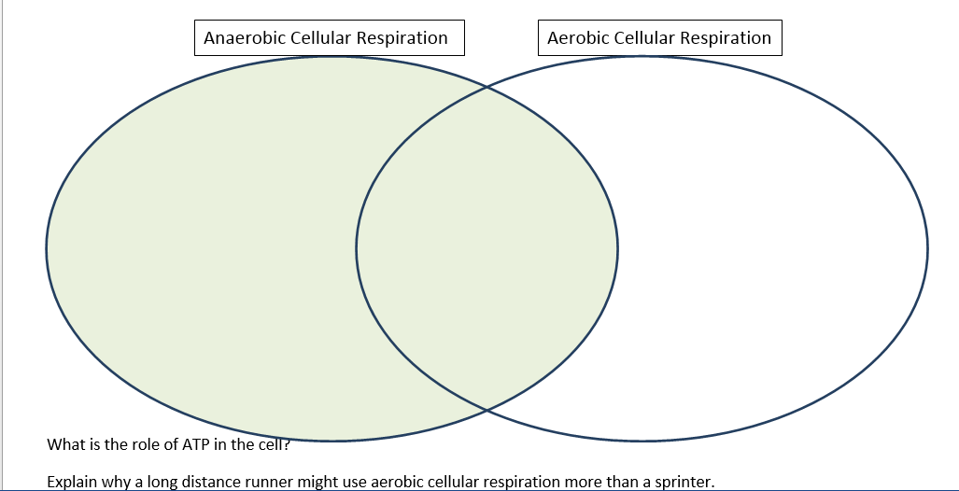

1. A plant and a snail occupy a small aquarium. The aquarium is exposed to sunlight for 12 hours a day and has 2 inches of water in it. What would happen to the snail if you removed all the plants from the environment?
   1. The snail would die from lack of oxygen
   2. The snail will die from lack of carbon dioxide
   3. The snail will have higher ATP production
   4. The snail’s mitochondrion will function better.
2. A plant and many snails occupy the same tightly closed aquarium. The aquarium is exposed to sunlight for 12 hours a day and has 2 inches of water in it. What would happen to the plant if you removed the snails?
   1. The plant would die from lack of glucose.
   2. The plant would die from lack of oxygen.
   3. The plant will thrive because it can undergo both processes of photosynthesis and cellular respiration.
   4. The plant will thrive because it can photosynthesize but then it will die because it cannot perform cellular respiration.

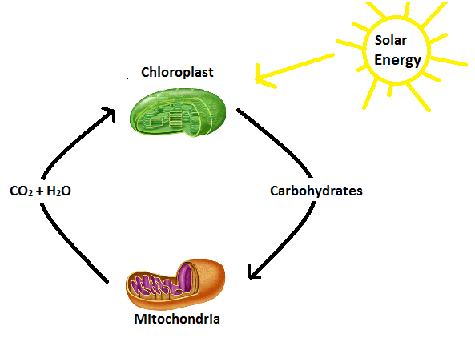

1. The diagram to the right shows the cycling of cellular respiration and photosynthesis.

What are the possible effects if water (H2O) is eliminated from this cycle?

1. Photosynthesis and cellular respiration will continue at a normal rate.
2. Photosynthesis would stop and cellular respiration would continue at a normal rate.
3. Photosynthesis would slow down and the rate of cellular respiration would increase.
4. Photosynthesis would stop and cellular respiration would slow down and eventually stop.