**Protein Synthesis Review Sheet**

**SC.912.L.16.5 Explain the basic process of transcription and translation, and how they result in the expression of genes.**

Traits, such as eye color, are determined by proteins that are built according to instructions coded in DNA. Recall that proteins have many functions, including acting as enzymes and cell membrane channels. Proteins, however, are not built directly from DNA. Ribonucleic acid (RNA) is also involved.

Like DNA, ribonucleic acid is a nucleic acid—a molecule made of nucleotides linked together. RNA differs from DNA in three ways. First, RNA consists of a single strand of nucleotides instead of the two strands found in DNA. Second, RNA nucleotides contain the five-carbon sugar ribose rather than the sugar deoxyribose, which is found in DNA nucleotides. Ribose contains one more oxygen atom than deoxyribose. And third, in addition to the A, G, and C nitrogen bases found in DNA, RNA nucleotides can have a nitrogen base called uracil—abbreviated as U. No thymine (T) bases are found in RNA. Like thymine, uracil is complementary to adenine whenever RNA base pairs with another nucleic acid.

A gene’s instructions for making a protein are coded in the sequence of nucleotides in the gene. The instructions for making a protein are transferred from a gene to an RNA molecule (called messenger RNA) in a process called transcription. Cells then use two different types of RNA (transfer RNA and ribosomal RNA) to read the instructions on the messenger RNA molecule and put together the amino acids that make up the protein in a process called translation. The entire process by which proteins are made based on the information encoded in DNA is called gene expression, or protein synthesis.

1. Label the diagram using the following words (some words may be used more than once) :

* DNA, DNA template, mRNA, Codon, ribosome, amino acid, polypeptide (protein)

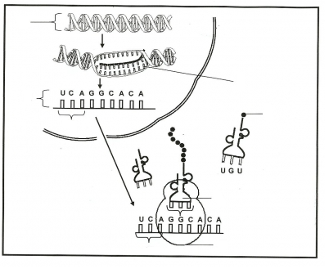

I.

B.

**A.**

C.

D.

F.

H.

G.

1. Describe the purpose of transcription and where it takes place:
2. Transcribe the following DNA strands into the correct mRNA strands:

CATCGATAGTCC = _________________

CGAGGTACGCAA = __________________

1. Describe the purpose of translation and where it takes place:
2. Translate the following mRNA strand into the correct amino acid sequence:

CGUAAGGGUCCC = _________________________________

AUGGGGCGACAA = _________________________________

1. The table below gives the codons found in messenger RNA (mRNA).



A scientist extracted a protein fragment from a cell. The fragment had the amino acid sequence: Trp-Met. Which of the following is a possible DNA sequence that is associated with this protein fragment?

1. UGGAUG
2. ACCTAC
3. GGUUGG
4. CCTTAC
5. A diagram of a cellular process is shown below.

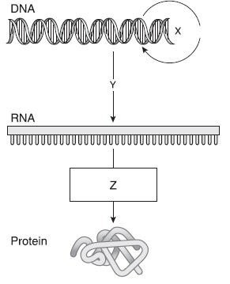

Which of the following identifies the process shown at point Z?

1. Translation
2. Translocation
3. Replication
4. Transcription
5. Part of an important cellular process involving a DNA strand is modeled below.

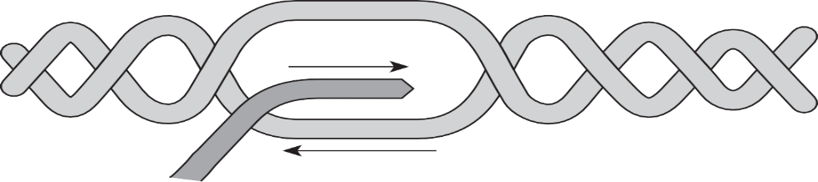

3’

3’

5’

What is the purpose of this cellular process?

1. Preserving genetic information for future generations
2. Deleting the information in the sequence produced from the DNA template
3. Transcribing information in the DNA sequence for use by the cell
4. Producing more nucleotides for the DNA sequence
5. A codon chart is shown below

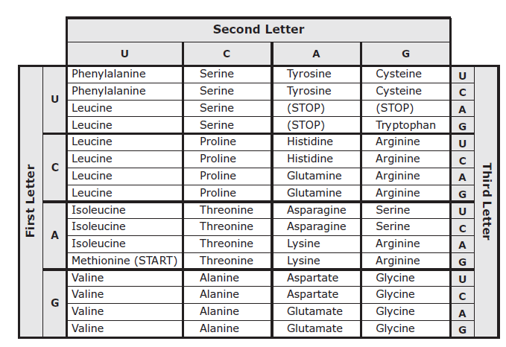

Which of these changes to the DNA triplet 3’ GCT 5’ will affect the protein produced?

1. GTT
2. TCC
3. TCT
4. GCA